(1) Four Castaways Make a Family
By Rene Denfeld The New York Times: Style August 11, 2017
https://www.nytimes.com/2017/08/11/style/modern-love-four-castaways-make-a-family.html

“I think you’re just right for her,” my adoption caseworker said, showing me her picture in the foster-child bulletin.

She was a dumpling of a child, her face unclear in the blurry black-and-white photo. The narrative underneath told me her private story, one I immediately embraced.

“Yes,” I said.

(2) Only a year old, she had already been shopped across states, featured in newspapers like an ad for used furniture. As with other waiting children, parental rights had been terminated, meaning if she wasn’t adopted, she would age out of foster care.

(3) When we met in a child welfare office, she was sitting in the lap of her foster mother, who looked so tired. My future daughter was one of too many children in the woman’s home; she was glad this one was being adopted.

“I hate to see them get bounced home to home,” the foster mother said, passing me my first child.

(4) I held her in my lap, paralyzed. I had brought a toy phone. When she grinned and reached for it, our eyes met, and a social worker took a photo of the moment. Later I wrote on the back: “The first time I saw you.”

(5) I didn’t understand why there wasn’t a stampede of parents to adopt her. That I would get the honor made me tremble. I was so in love I could not say her name to myself, even in a whisper, lest I be denied the joy: Luppi Milov. I thought it was the most euphonious name I had ever heard. My daughter, my love.

(6) As far as I knew, I was capable of getting pregnant. I just didn’t want to. There were half a million children in foster care in need of an adoptive parent. And I wanted children, so this made perfect sense to me.

It didn’t make perfect sense to my friends.

(7) “Aren’t you afraid?” they asked.

No, I wasn’t. I had grown up with poverty, abuse and molestation. If my daughter wasn’t worth saving, neither was I. Besides, I didn’t believe that biology guaranteed love. I had grown up in a biracial family, unrelated to one of my siblings and half-related to others, and I certainly didn’t love them half as much.
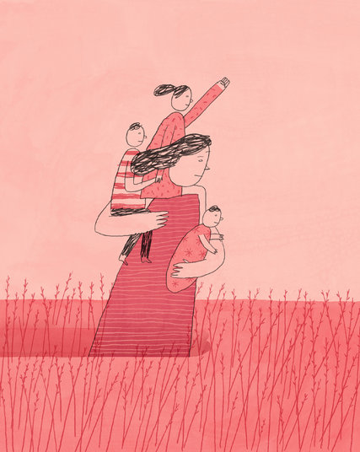
(8) Adopting from foster care felt magical. There was a wildness of imagination to it, a proclamation of intent: a decision to love.

Of course, ideals are one thing, reality another. The first months of motherhood hit me like a lead-filled gunnysack, my free time absorbed by occupational therapy appointments, doctors and specialists. (9) I stayed up late reading books, learning about her challenges. Preschool started with special education looming, but I decided she was perfect just as herself.

And just like that, she bloomed.
(10) Three years later, my caseworker said those magical words again, with a twist: “I think you’re just right for him.” This time the photo was clearer: a darling little boy with cherub cheeks. His eyes told his story; I had seen terror like that before, in my own eyes, looking back at me from my own childhood mirror.

“I’ll call him Tony Baloney,” my daughter said, dancing around her new little brother. She was now 4 and a shot of pure joy.

(11) We met in his foster home, where his experienced foster parents didn’t mince words. Tony had bounced from home to home. He had serious attachment issues, rage. While we talked, Tony tore after another child; I heard cries of pain from down the hall.

(12) Back in our home, Tony pulled down the shower curtain, threw the dog dish at me, bit me, trashed his room. I often found myself in our bathroom, shaking with anger and disappointment. It’s hard to love a child who doesn’t love you back. But I knew I couldn’t fail Tony. To fail him would be to fail the lost child in myself, the memory of the anger I had and my desperate desire that someone love me through it.

(13) I decided I would fake it until I made it. When he raged, I told him I loved him. I told him over and over.

We saw a child psychiatrist who suggested floor time, a method where you sit with the child for hours on end playing games at his lead. It sounds simple, but it was transformative. Every morning, I woke to find Tony standing by my bed.

(14) “Floor time, Mama? Floor time?” he would ask, and before I could make myself a cup of coffee, we were on our special rug and I was nodding as Tony acted out all the hurt he had experienced. He buried children in dungeons, put them on trains and sent them away. Sometimes I was allowed to help. Mostly he wanted me to watch, to bear witness.

(15) For all his fury, Tony never tried to hurt his sister. She followed any game he wanted to play and took his rages in stride. “He’s afraid we’re going to give him away,” she told me, solemnly.

For years, Tony kept his emotional suitcases packed by the door, seeing if we would send him away. (16) “I’m stronger than Superman,” I told him, wondering if I believed it. “I don’t give up.”

Slowly, the rages abated until they stopped. One day, he looked up from playing with a truck on the floor, and his eyes were soft, no longer terror-filled.

(17) “You brought me home,” he said. He returned to his truck and said in a quiet, firm voice, “I love you too.”

Another six years passed before my caseworker said it again: “I think you would be just right for him.”

(18) This boy, an infant, was a day apart in birthday to Tony, with a strangely similar birth name, but he was pure magic too: Markel Antoine. I looked at his picture a dozen times a day, saying my secret prayer: Please let him be mine.

(19) The answer was yes. Out came the stroller, occupational therapy games and Rolodex of specialists.
His foster parents had been trained to care for medically fragile infants. (20) They had propped him between pillows, and he sat there, his eyes lighting up at the sight of us. Luppi and Tony were now 9 and 7. They held Markel, delighted, in their laps.
“You know he doesn’t sleep, right?” the foster mother asked me.

I knew.

(21) “You know he screams all night?”

I knew.

“You know his future is uncertain?”

I knew.

I felt like such an old hand by now that I could handle anything. (22) I had learned to enjoy the process with these so-called difficult children, and it was rewarding to see the growth. I was delighted by the truth that you have to accept children just as they are before they can change. Like his siblings, Markel soon flourished.

(23) I had come to believe that the most important therapy is permanence. Children can sense when they are in a temporary home. All my children grew rapidly once settled, going from below the fifth percentile in height and weight to close to average. More important, they grew emotionally. It is love that feeds the soul, allows us all to flourish.

(24) “Are they siblings?” people often asked when we were out and about, when they realized I had adopted.

“They are now,” I would answer.

“You must be brave,” they would say.

(25) I never knew how to respond to that. I never felt brave. Maybe the question assumes we need special courage to mother a child we have never met, but isn’t that true of all children? Even when pregnant, we don’t meet our child until he or she is born.

(26) To be a parent is to step into a great unknown, a magical universe where we choose to love over and over. It is an act of courage no matter what.

“Didn’t you want your own?” people would ask.

“They are my own,” I would say, softly.

(27) By adopting from foster care, I became the mother I had needed and rewrote my own story. I got to have a childhood all over again, the right one, filled with cuddles and perseverance, safety and love. If there is such a thing as a cycle of abuse, I broke it over the wheel of my own desire.

(28) It has been 20 years since I first adopted. Luppi, Tony and Markel are now thriving and well adjusted, working and going to school. If you met them, you wouldn’t guess their histories. But if they told you, that would be O.K., too, because there is nothing shameful about their pasts, or mine.

(29) Recently we took a family vacation, flying from Oregon to Phoenix for four days. The kids horsed around in the pool, and I took a lot of pictures of them, grinning and full of life.

My caseworker had said all those years ago that I would be just right for them. As it turned out, they were just right for me.
Rene Denfeld, who lives in Portland, Ore., is the author of the novel “The Child Finder,” out in September. modernlove@nytimes.com

