(1) Excerpt from:
Homeland Elegies
by Ayad Akhtar, p. 298-300
New York: Little, Brown and Company
Hachette Book Group, September 2020

“I don’t see parking,” I said.

“It’s probably in back. Use that Kwik Mart,” he said, indicating the gas station convenience store adjacent to the library. “I’ll go in and get a few things.” I slowed and signaled, then turned in to the parking lot. If I wasn’t particularly mindful about my parking angle, it was because I didn’t have any reason to be.

Father pushed open his door. “You want something?”

“I’ll come with you. I need to use the bathroom.”

(2) Behind the register inside was another heavyset young woman; she was staring down into her phone. The odors here were pungent, off-putting: the burned coffee and cleaning bleach, the desiccated wieners slowly turning on the roller grill. Father headed for the row of refrigerated cases displaying beer. I wove my way through the aisles to the bathroom in the back corner. When I came back, I found Father perusing a rack of potato chips, a six-pack of beer nestled into his armpit. I noticed a narrow, clean-cut man in the store now, maybe forty, with a furry head of white-blond hair shorn close to his skull. (3) He was standing at the press rack by the register, magazine in hand—but he wasn’t reading: he was watching Father and me. I heard him speaking, but I wasn’t sure to whom. “Fucking rule of law. There’s laws for a reason,” I thought I heard him say.

“You want some chips or something?” Father asked me sweetly.

“I’m fine. I’ve still got water in the car.”

(4) He nodded and headed for the register.

As we approached, the blond man held his ground, staring at us as Father laid out his merchandise before the clerk.

“Will that be all?” she asked without interest.

“That’s it,” Father said.

“—You know, there’s rules for a reason,” the blond man blurted, clearly addressing us.

Father looked over at him, confused. “I’m sorry. Were you in line?”

“I’m sorry. Were you in line?” the man repeated, mocking.

I saw Father bristle. “Is there a problem, sir?”

“—Dad.”

“I don’t know, sir—is there?” the man shot back with a smirk. (5) His small teeth were gnawing on a piece of gum. To call the thin row of hair above his upper lip a mustache wouldn’t exactly have made sense.

“We don’t want any trouble,” I said, stepping forward to pay. I dropped a twenty on the counter and indicated I didn’t want change.

The blond man snickered loudly: “No trouble? So let me ask you, is that your car out there?”

The clerk interjected wearily: “Chuck, these folks are just trying to buy some stuff. You want to leave it alone?”

“I leave it alone when they fucking learn how to drive in this country.”

(6) “What country? Hmm—?” Father snapped. “What country is that?”

“Dad. Let’s go—” I said, grabbing the beer from the counter with one hand and Father’s elbow with the other.

“This fucking country, you monkey. This is not some zoo. We got rules here. Rules of fucking law. Learn how to park your fucking car in the United States of America.”

“Monkey!? Monkey?!” Father shouted back as I snatched him to the door and pulled him through it.

Outside, I saw my offense: an admittedly blithe parking job that had the front end of our car pushing into an adjacent spot. (7) Two spots over, a Ford pickup was gurgling, with no one in the front seat. Mounted to the grille was a cracked buck’s skull and an uneven coil of bony antlers protruding from it. Behind us, Chuck emerged outside just in time to hear me urge Father to get in the car.

“Yeah, that’s right, Dad. Get in the car. Monkey say, monkey do.”

Father turned toward him, screaming. “Will you shut up!!!”

“Dad. Stop it. Get inside,” I said, pushing him into the passenger’s side, my blood racing.

“Can’t wait ’til we build that wall to keep you fucking apes out.”

(8) “You’re the fucking ape!” Father shouted. As ever, that most natural of American imprecations sounded decidedly unnatural on his lips: “Fucking ignorant! Don’t want to work and don’t want anyone else to!”

“Why don’t you fuck..ck..ck..ing learn to speak-a-English—”

“—We speak it just fine,” I spit back at him.

“Oh, nice. So the monkey boy’s got some lip on him, too.”

“Go fuck yourself,” I added as I pulled at the driver’s-side handle. My reflexive glance to note his reaction revealed something I’d missed until now: a strap led down one side of his torso to a leather bulge on his flank.

(9) He saw me notice his gun, and he smiled: “Can’t wait when we build that wall to keep you critters out.” What I felt in that moment was brief, but I won’t ever forget it. The sight of the gun, the visceral threat and primal fear it triggered, the elemental urge to protect myself, the asymmetry of our power in that moment “—all of it combined to set something ablaze inside me I’d never experienced before. I wanted to kill him. But the immediate awareness of just how powerless I was to do so threw me back onto myself in a way that eats at me to this day, almost two years later.

(10) Father was saying my name, trying to get my attention. I finally found his eyes. “Let’s go.” His measured tone was filled with alarm.

Chuck began to say something about the wall again, but I didn’t hear most of it. He stepped forward as I started the engine. His hand found its way to his piece as I reversed. Behind him, in the doorway glass, I saw the clerk standing and watching as she munched on chips. I put the car into drive, accelerated onto Main Street, past the library, and out of town.

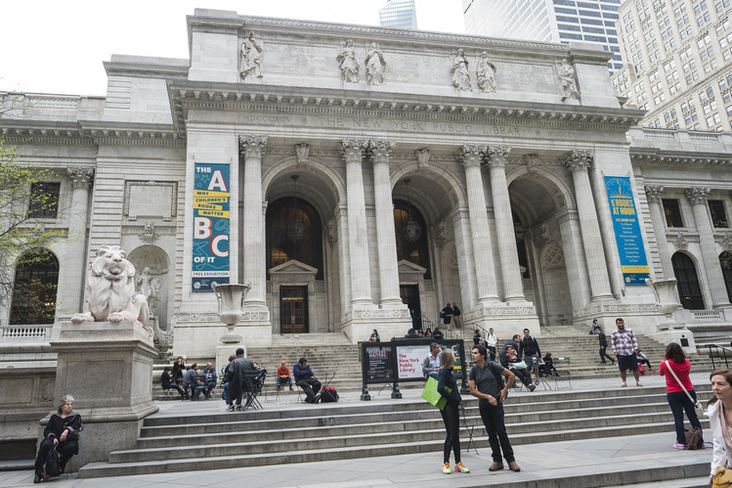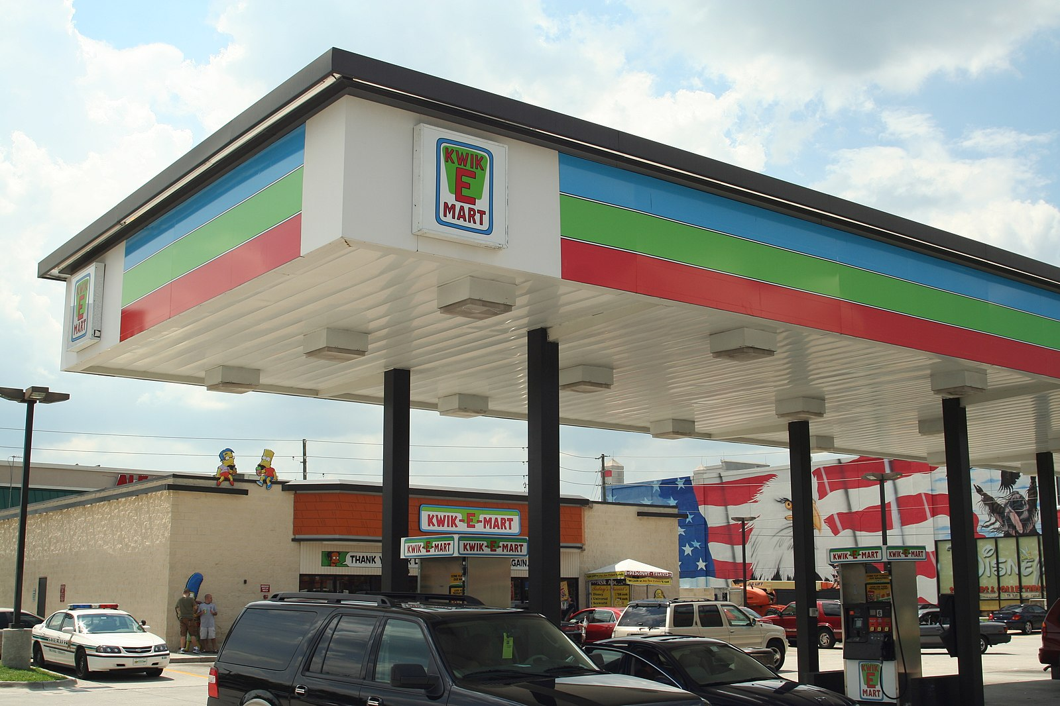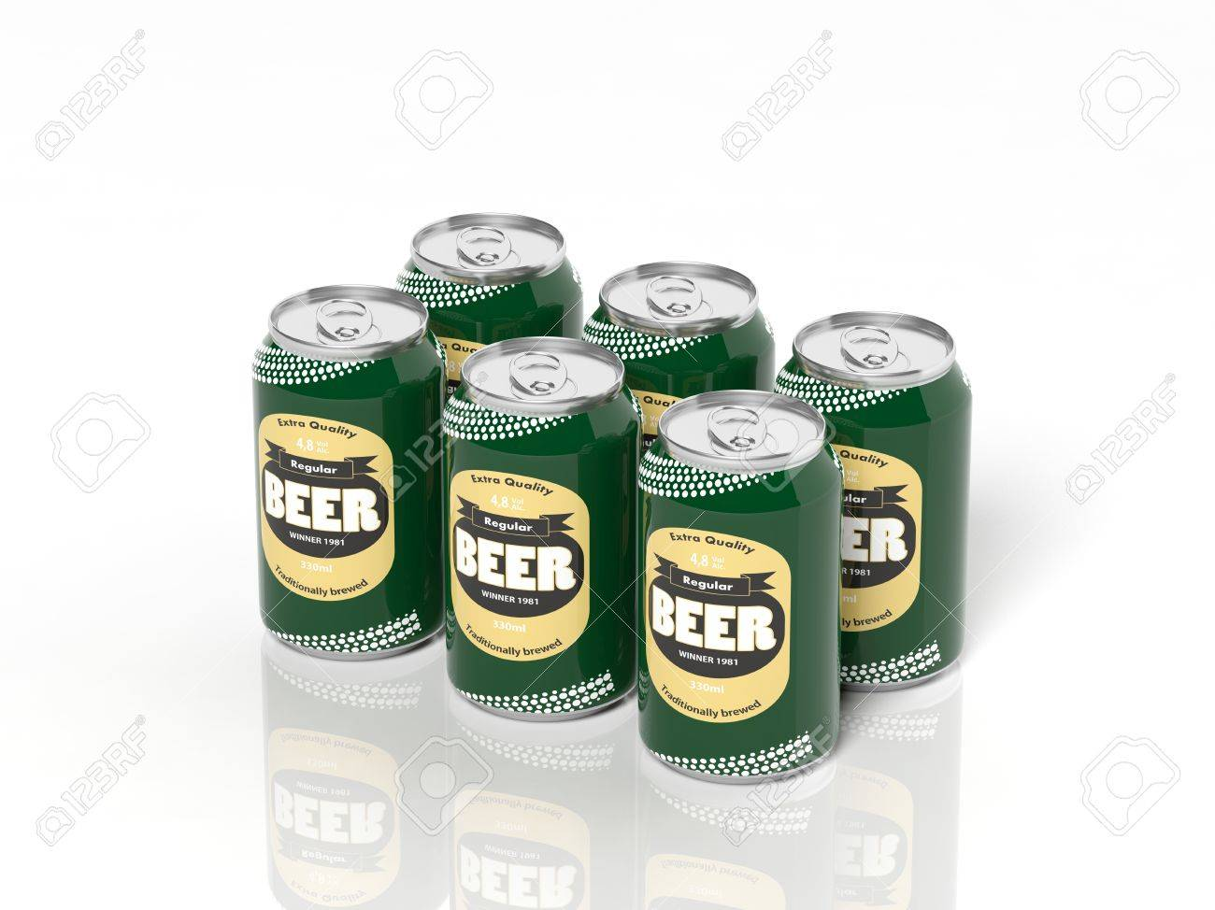
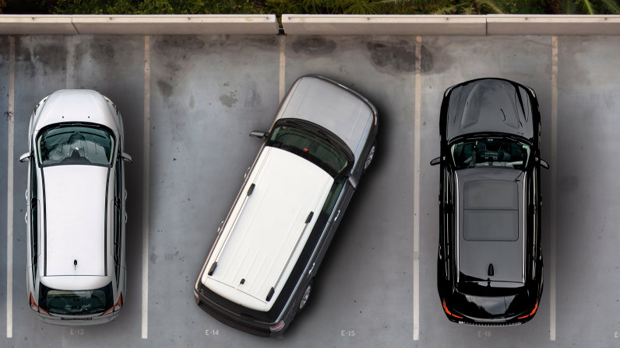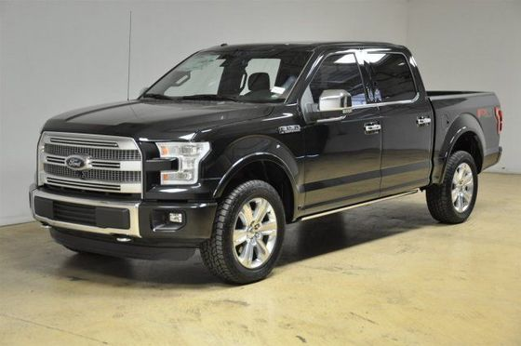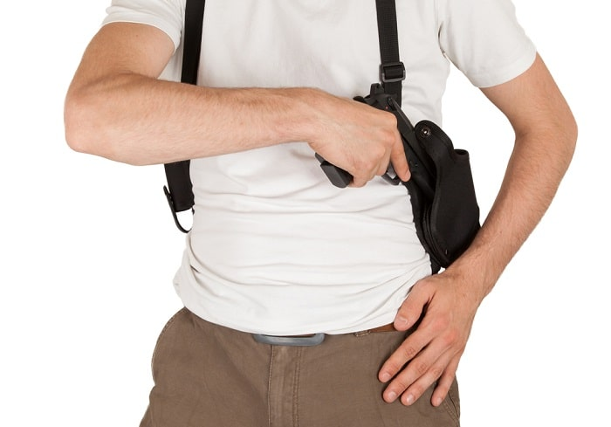
Image sources:
https://www.wsj.com%2Farticles%2Fnew-york-public-library-scraps-redesign-plans-1399489571
https://commons.wikimedia.org/wiki/File:Kwik-E-Mart_Gas_(760593543).jpg
https://www.gq.com/story/how-to-dye-your-hair-blonde-this-summer
https://www.123rf.com/photo_35758214_3d-six-pack-collection-of-beer-cans-isolated-on-white.html
https://people.howstuffworks.com/taking-up-two-parking-spaces-illegal-ticket.htm
https://en.wikipedia.org/wiki/Ford_F-Series
https://bobergarms.com/shoulder-holster/

