CET Pronunciation Workshops 2020: Vowel Workshop
Karen Steffen Chung 史嘉琳 台大外文系 副教授

Karen’s TEDx talk: https://www.youtube.com/watch?v=sQEWEPIHLzQ
Karen’s interview with 阿滴: https://www.youtube.com/watch?v=16kkr2eGSdE&t=96s
Karen’s interview on the “Linguistics is Fun” podcast: https://m.mirrormedia.mg/story/20191104cul002/
Series of articles in Chinese on English learning and pronunciation in CET’s HellO! E.T. and English Island:
http://homepage.ntu.edu.tw/~karchung/Karen/Karen_Chung_publications.htm#CET
Online Phonetics Course 語音學on NTU Open Course Ware 台大開放式課程page:
http://ocw.aca.ntu.edu.tw/ntu-ocw/index.php/ocw/cou/101S102
Subscribe to Email updates: http://eepurl.com/505qT
Articles on Vowels:
- 師德會訊：大師開講：台式英語罪魁禍首：/æ /、/ɛ/ 和 /eɪ/
in No. 79, September/October 2013, p. 12-14
http://homepage.ntu.edu.tw/~karchung/pubs/CET79.pdf

- 英語島：台灣味學習法：用注音練英文母音
in No. 24, December 2017 https://www.eisland.com.tw/Main.php?stat=a_O1zg9Uh&mid=36

- 英語島：連音：英語「字裡行間」的玄機 - 母音篇 2018-7
in No. 31, July 2018 http://www.eisland.com.tw/Main.php?stat=a_AO4wy0h&mid=36

- What can happen if you're sloppy about your vowels:
英語島：你有沒有不小心講出「限制級英文」?
in No. 10, October 2016 http://www.eisland.com.tw/Main.php?stat=a_0GECDzr&mid=36

When the English tongue we speak
Published in The Spectator by Lord Cromer, August 9, 1902
YouTube: https://www.youtube.com/watch?v=FmAaX0kREGQ
http://www.seeyouspeak.com/CLASSROOM/Tips/files/20431f074d774d825a76c675fcef6106-71.html
(1) When the English tongue we speak,
Why is break not rhymed with freak?
Will you tell me why it's true
we say sew, but likewise few,

(2) And the maker of the verse
Cannot cap his horse with worse?
Board sounds not the same as heard;
Cord is different from word;

(3) Cow is cow, but low is low;
Shoe is never rhymed with foe.
Think of hose, and dose and lose,
And of goose, and yet of choose.

(4) Think of comb and tomb and bomb,
Doll and roll, and home and some,
And since pay is rhymed with say
Why not paid with said, I pray?

(5) We have blood and food and good;
Mould is not pronounced like could.
Therefore done, but gone and lone?
Is there any reason known?
and, in short, it seems to me
Sounds and letters disagree.
A. What is a vowel?
- Unlike a consonant, a vowel is an articulation in which there is little or no contact between organs of articulation 發音器官 in the mouth, so the air coming up from the lungs passes through oral cavity 口腔and out of the mouth quite smoothly, without obstacle.

- In general, all vowels are voiced, that is, the vocal folds vibrate when you say them.
(Feel your throat!)
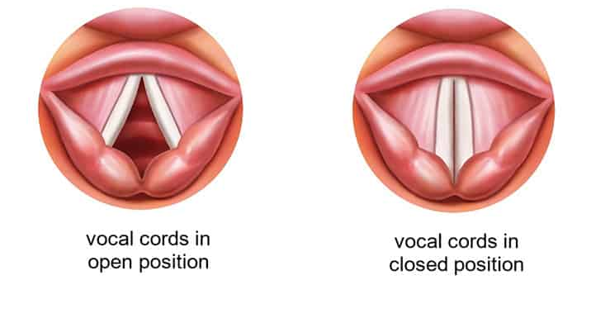
https://www.childrens.health.qld.gov.au/fact-sheet-vocal-cord-palsy/

Video: Fantastic Voyage: A journey into the human voice
https://www.youtube.com/watch?v=x_X83_EolcQ
- A vowel will have a specific pitch, and is usually more sonorous 響亮 than a consonant.

- A vowel has a relatively long duration, compared to most consonants.

- You produce different vowels by moving the tongue into different positions in the oral cavity.

- The vowel is determined by the position in the mouth of the “humped” or tense part of the tongue.

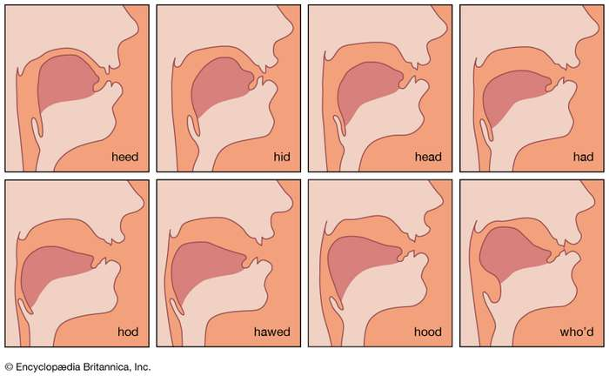
https://www.britannica.com/science/phonetics/Vowels
/i ɪ ɛ æ/
/ɑ ɔ ʊ u/
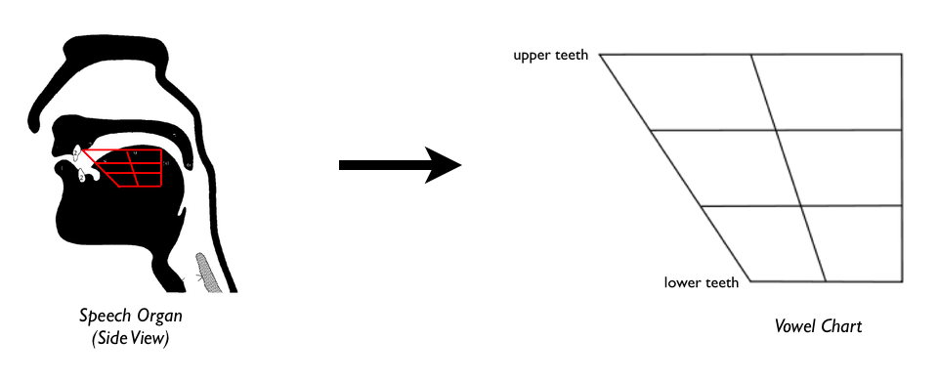
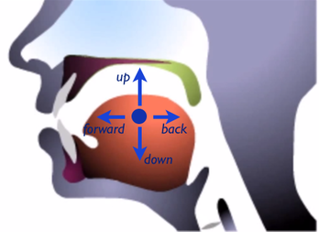
http://english.mimicmethod.com/english-vowels.html

- A vowel with just one steady position is called a monophthong 單母音 or 單元音.

- A vowel that moves from one position to another, that is, it includes movement between two different tongue positions in the same syllable, is called a diphthong 雙母音 or 複元音.

- General American English has 16 vowels, including:

10 monophthongs 單母音:
/i ɪ ɛ æ ʌ ɑ ɔ ʊ u/ and /ə/

and 6 diphthongs 雙母音:
/aɪ eɪ aʊ oʊ ɔɪ ju/
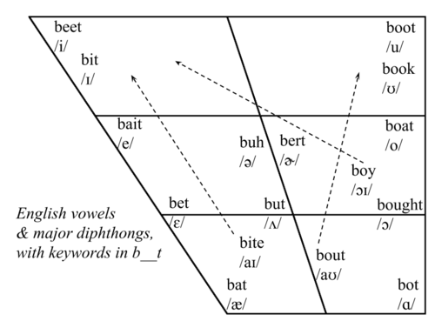
Note regarding 2 diphthongs: Instead of /e/ and /o/, we’ll be using the standard IPA symbols /eɪ/ and /oʊ/.
Mid-sagittal view of the head showing vocal tract and articulatory organs

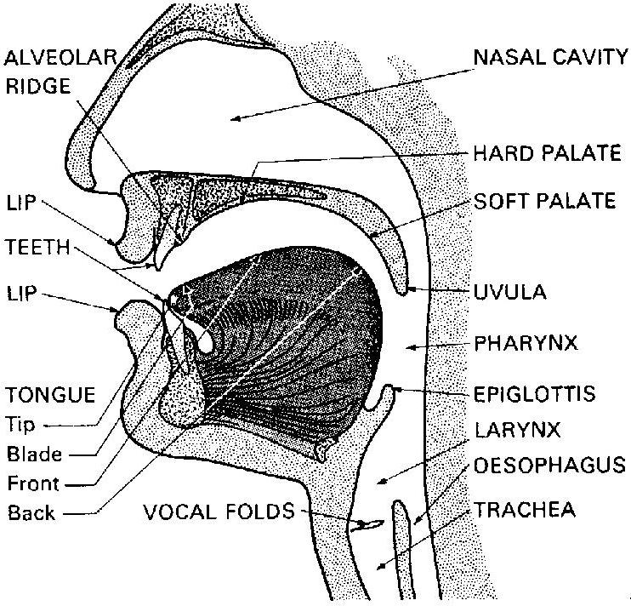

B. Almost all of the vowels in US English have a very close equivalent vowel in Mandarin or Southern Min. The following illustrate some of the equivalencies between Mandarin and Southern Min vowels and English vowels. Some are not perfectly the same, e.g. /u/ andㄨ, but they are very close, and easy to adjust once you have the general idea.

“1” vs.

/æ/ → /ɛ/

Game show: Which word did you hear, a. or b.? Or: /æ/ or /ɛ/? Refine the design.

1. spanned / spend
2. tampered / tempered
3. alimentary / elementary
4. treks / tracks / tricks
5. ember / amber
6. maladies / melodies
7. expending / expending
8. celery / salary
9. fanatics / phonetics
10. threshed / thrashed

Velar raising: Vowels can change according to context. Consider Mandarin: ㄚ ㄢ ㄧㄢ ㄤ (a an ian ang). The three front vowels: /ɪ ɛ æ/ sound more like /i e e/ when followed by /-g/ or /-ŋ/. Examples:

pick pig pin ping
Bic big bin bing
kick kin king
sick sin sing
tick tin ting
wick wig win wing

peck peg pen
send strength
lend length

tack tag tan tang
back bag ban bang
backs bags bans bangs
pack pan pang
rack rag ran rang

A single vowel letter “o” (not “oa” or “o” + silent “e”) is often pronounced as /ɑ/ ㄚ in American English, e.g. hot /hɑt/ and Tom /tɑm/ – watch out for it!

/ɔ/ as in “law”, “caught” and “gone” is a long vowel that sounds a little like Southern Min 芋仔 read as one syllable instead of two. Write /ɑ/ or /ɔ/ above any vowel you need a reminder for.

ㄚ vs. 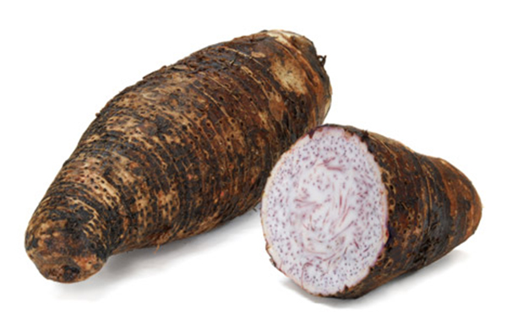

vs. 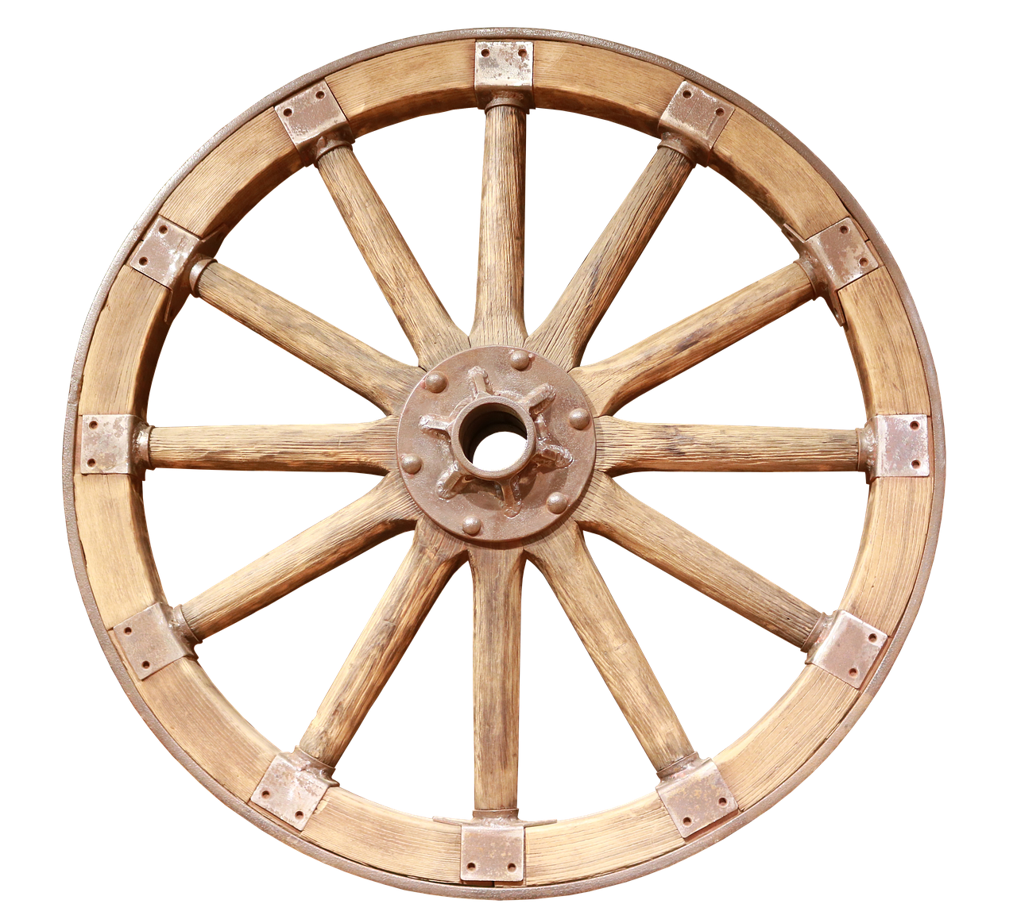

Watch out for: put vs. pull vs. pool

ㄜ and ㄦ

ㄞ ㄟ ㄠ ㄡ （拉長）

Practice with /eɪ/ + final nasal:

My dame has a lame tame crane,
My dame has a crane that is lame.
Please, gentle Jane, let my dame’s lame tame crane
Feed and come home again.

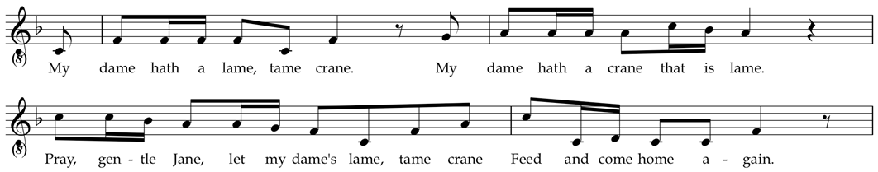

ㄛㄧ and 幼 (ㄧㄨˇ: 台語)
Note: /ju/ → /u/
after /d, t, n, l, r, s, θ, ʃ, ʒ, tʃ, dʒ/
Just remember: ㄉ ㄊㄋㄌ
e.g. duty, tube, new, lure
Also: duty, due, dew, dude;
tune, tuber, tutor, tulip;
newspaper, nuclear, neutral, neutron;
Luke, Lucy, lubricate, lunatic

C. When is a vowel longer or shorter?
- If a vowel is followed by a voiceless consonant, it is not extra long, e.g.:
tap keep lip type
cut right not put
pick like make take
cash kiss leash calf
cuff bath touch laugh

- If a vowel is followed by a voiced consonant, it is quite a bit longer, i.e. it is lengthened by about half a beat, e.g.:
cap/cab rip/rib rub lap/lab
food sat/sad did red
dick/dig rug log tack/tag

cam rim fun ten
wing rung will fur
save buzz garage judge

- If a vowel is in an open syllable, it is lengthened a lot:
see spa saw clue
try bay cow so
toy cue stay high

- Compare – short to long, then backwards for long to short:
seat seed seen see
tight tied time tie
pick pig ping pea
rip rib rim Rhee

- The more syllables a word has, the shorter each vowel in each syllable, including the vowel in the stressed syllable, will be:
speed speedy speedily
care careful carefully
stand standing outstanding understanding
air airplane airworthy airworthiness

- Linking: When the next word starts with a vowel, remember to link the last sound of the previous word to it, as though it were the first sound of the next word.
Consonant to vowel – watch out for the tap [ɾ]!

time for‿a bite to eat‿after
I guess‿I do
look‿open
got‿it
figured‿it‿out
what‿are you
I’m‿a little hungry
I think‿I’ll get
they’ve had‿it
quite‿a while
what‿I said
tar‿in it
great‿idea
save‿a bite

Vowel to vowel:

to‿eat
how‿about
here we‿are
go‿in
so‿it’s
menu‿item
maybe‿I’ll have

Short dialogue practice: A bite to eat

Cathy: Would you have time for a bite to eat after we finish here?  David: Uh, well…yeah, I guess I do.  Cathy: (Outside office, walking) Where would you like to go?  David: Mm, how about Coffee Break? They’re /kloʊːz/.  Cathy: (Gives David a confused look) | https://flic.kr/p/89bwyu
David: Here we are…
Cathy: But they look open to me…
David: Yes, let’s go in…
Cathy: Oh! You meant they’re /kloʊs/ close! Ah, got it!
David: Something wrong?
Cathy: Mm…no, figured it out! What are you getting?
David: I’m a little hungry. I think I’ll get the /pɛn/ (pen) pizza.
Cathy: …So it’s shaped like something to write with? A new menu item?
David: Actually no, they’ve had it for quite a while…
Cathy: Ah! The personal /pæn/ (pan) pizza?
David: Yes. Isn’t that what I said?
What are you having?
Cathy: Mm…maybe I’ll have the /pɪtʃ/ (pitch) cobbler.
David: Uh…a dessert with tar in it?
Cathy: Huh?
David: Oh, sorry, I know...the /pitʃ/ (peach) cobbler!
Great idea! Save a bite for me!

- English Vowels

Vowel | Description | Example
 | forward vowel | as in beet
 | forward vowel | as in bit
 | diphthong | as in bait
 | forward vowel | as in bet
 | diphthong | as in bat
 | diphthong | as in by
 | diphthong | as in house
 | back vowel | as in boot
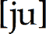 | diphthong | as in abuse
 | back vowel | as in book
 | diphthong | as in boat
 | back vowel | as in awe
 | diphthong | as in boy
 | back vowel | as in father
 | central vowel, stressed | as in bud
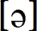 | central vowel, unstressed (schwa) | as in appeal
 | central vowel with r, stressed | as in burr
 | central vowel with r, unstressed (hooked schwa) | as in butter

- English consonants

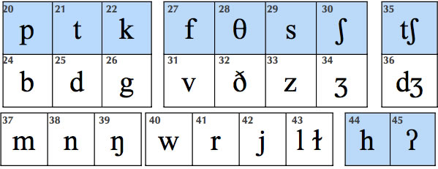

From previous workshops (for REFERENCE ONLY; we will NOT cover this in this workshop):

Step 1. Phrasing 斷句:

Always think of your LISTENER when speaking and reading!
Taiwanese tend to race to the finish when reading, with almost no pauses, making it difficult for listeners to understand. The reader will also not usually understand what they’re reading, and they will sound stressed and nervous. Conscious learning of where to pause can fix this!

Read through the texts above, | marking shorter pauses | (e.g. marked by a comma, | or no punctuation) | with |, and longer ones | (e.g. marked by a semi-colon or period) | with || in (1)-(4). ||

Pause:
- After the complete subject 完整的主詞前
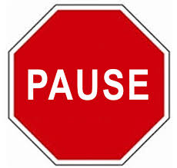
- Before “that” and other clauses “that” 等子句前
- At most punctuation marks 遇到標點符號時
- Before conjunctions 連接詞前
- Before prepositions 介系詞前
- Before and after parentheticals 插入語 (e.g. Ted, unfortunately, couldn’t come.)

Step 2. Mark intonational stress
Three Basic Rules of Intonation:
1. Stress content words
(nouns, verbs, adjectives, some adverbs);
don’t stress function words
(articles, conjunctions, prepositions, pronouns,
helping verbs, “be” verbs, some adverbs).
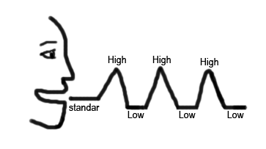
2. Stress new information; don’t stress old information.
3. Stress contrasted words; everything else is unstressed
(a low, flat tone).

DON’T stress the syllables you shouldn’t!
Remember that English stress is usually marked by a higher pitch;
unstressed syllables are often read in a string with a low, even pitch,
much like an extended Mandarin third tone, e.g. She wasn’t even thinking about you | when she *did it.

— — — – — THINK _ _ __ _/ | — — *DID _

Underline all stressed syllables.

Step 3. Mark *tonic stress:
The last stressed *syllable in every phrase or *thought group gets an especially high (or low) into*national stress. This is called *tonic stress. We’ll mark it with an *asterisk.
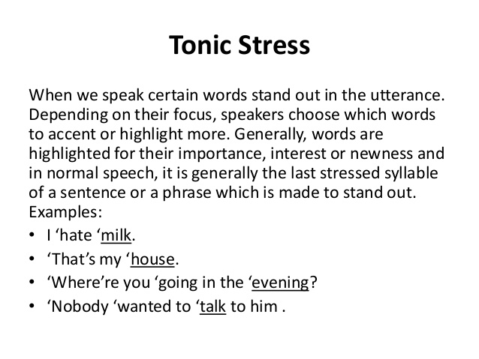

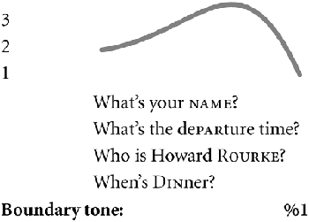
Step 4. Mark final falling and rising intonations
If you’re at the end of a complete idea or sentence –
usually marked with a period . or semi-colon ; , use a falling intonation.
Wh- questions (asked with who, what, where, when, why, how, which,
and how) also have a falling intonation. Mark with a high-falling line.
Mark yes-no questions with a rising intonation. All clear?
Step 5. Mark all of the continuation rises ʅ, both large and small
Taiwanese students tend to have a falling intonation at the end of all phrases.
But there should be a rise at the end of most phrases that aren’t the end of a sentence.
ʅ
The highest point is the tonic stress,
then it drops down low, and then there’s a gentle rise.

Practice using the continuation rise where called for.
Mark all of the continua tion rises with a line as indicated.

Mark the continuation rise over the following intonational chunks of one to six syllables:

…with my friend, …
…with my mother, …
…with a relative, …
…with a relative there, …
…with a relative of mine, …
…with a relative I don’t know…

Step 6. Circle in red all of the vowels pronounced /eɪ/
Be careful to pronounce them as ㄟㄧ, NOT as /ɛ/ or /æ/.
Be especially careful when /eɪ/ comes before a nasal consonant,
i.e. /eɪn/ and /eɪm/, as in sane /seɪn/ and same /seɪm/.

Step 7. /ɑ/ and /ɔ/
A single vowel letter “o” (not “oa” or “o” + silent “e”)
is often pronounced as /ɑ/ ㄚ in American English,
e.g. hot /hɑt/ and Tom /tɑm/ – watch out for it!

/ɔ/ as in “law”, “caught” and “gone” is a long vowel
that sounds a little like Southern Min 芋仔 read as one syllable instead of two. Write /ɑ/ or /ɔ/ above any vowel you need a reminder for.

Step 8. /s/ vs. /z/: Draw a wavy underline under all letter “s”s that are pronounced /z/

Watch your “s”s – some should be pronounced /z/, as in lose, raise, days, and diseases!

Step 9. Compound Noun Stress

In compound nouns, i.e. noun + noun expressions, only the stressed syllable of the modifying noun is stressed. Adjective + noun expressions with special meanings are stressed in this way too. These expressions are stressed as though they were one word.
Examples: con*venience store, *peanut butter, *exercise bike, *newspaper, *girlfriend, *boyfriend, *bookshelf, com*puter desk, *airplane, in*surance salesman, *car door;
*hot dog, *greenhouse, *blackboard

Step 10. Watch out for the pronunciations of these common words and mark if needed:

of [ʌv] or [əv], as [æz], because [bi ‘kʌz], she [ʃi] (NOTㄒㄩ),
says [sɛz] (not [sez] or [seɪz]), said [sɛd] (not [sed] or [seɪd]), ask, asks, asked.
Step 11. Voicing affects vowel length

If the final sound of a syllable is voiced, the vowel that precedes it must be lengthened. Contrast the following: cap/cab [kæp]/[kæːb] lit/lid [lɪt]/[lɪːd] duck/dug [dʌk]/[dʌːg]
lap/lab; mop/mob; pup/pub; cop/cob; rope/robe; bit/bid; pat/pad; sit/Sid; set/said; mutt/mud
Step 12. Mark linking

When a word starts with a vowel, link the last sound of the preceding word to it, and read the two
as though they are one word, e.g.: when I [wɛ ̬naɪ], people are ['pipə ̬lɑr].

Step 13. Watch out for schwas [ə], i.e. the reduced vowel in some unstressed syllables

Schwas are often found in unstressed syllables, e.g. conceited /kən'sitəd/, and in function words like to, of, or, in; don’t read them as full vowels!

ə ə ə
Add a schwa symbol [ə] over unstressed, reduced vowels.

Step 14. The “tap”
In US English, when a “t” that comes between two vowels, and the syllable to the right is unstressed, the “t” is pronounced like a very short /d/, and is called a “tap” or “flap”. The symbol is [ɾ].
ɾ
Write a “tap” symbol ɾ above “t”s that should be pronounced as “taps”.

Step 15. Remember your “r”s!

Taiwanese often omit “r” sounds after vowels, e.g. in farm, large. Don’t! Almost ALL “r”s are pronounced in US English! Make them a strong, Beijing-style ㄦ sound!
√ √
Add a check √ above each “r” following a vowel if you tend to forget them.

More: How you sound to others before working hard on your pronunciation:
https://www.youtube.com/watch?v=w8MlL2GhhOw&t=43s

Poor pronunciation…
• affects understanding
• makes other people tired as they struggle to understand you
• makes others think you are less intelligent than you are
• will affect your social life

Priorities, commitment, new HABIT formation
One Small Step Can Change Your Life animated by Nathan Lozeron
Also: How to Build Habits & Execute Effortlessly https://www.youtube.com/watch?v=w8MlL2GhhOw
https://www.youtube.com/watch?v=-LdhudFvJuE 1-page pdf
Ask yourself:  - Do I really want to improve my English?  - How high a priority is it for me?  - If it is a high priority, then I will find a time  to work on my English DAILY.  Take baby steps! But do it EVERY DAY!  Make it AUTOMATIC! | 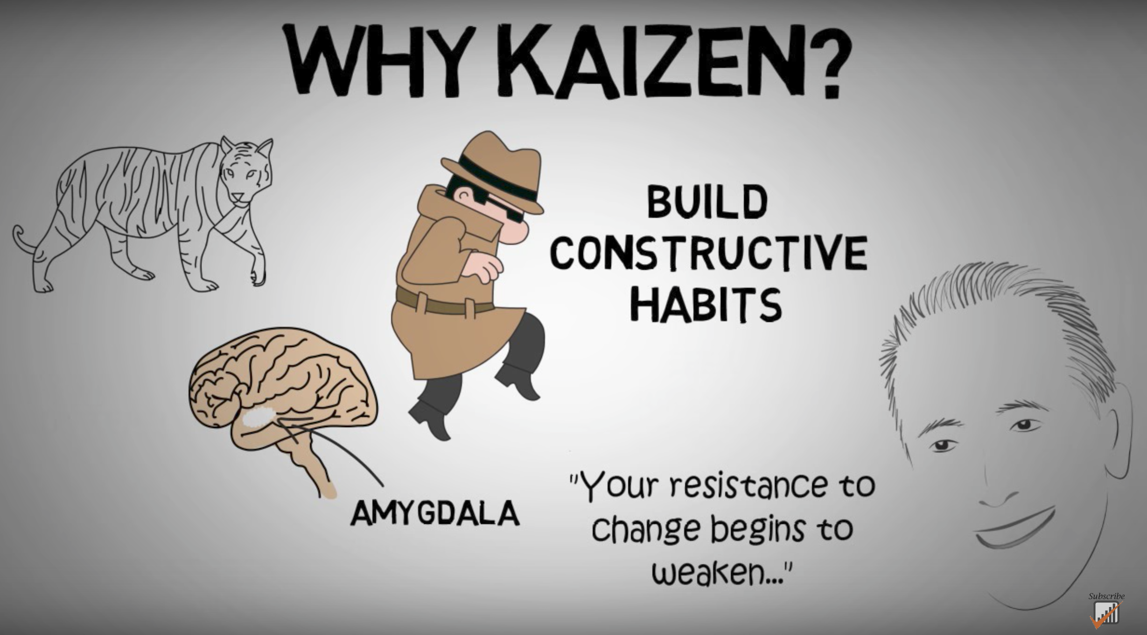  https://www.youtube.com/watch?v=VHkOFs67d9A

When, where, what?
- I will work on my English for 10-15 minutes starting from _____:_____ am / pm EVERY DAY.
- I will work on my English here: ___________________________.
- I will practice with these materials: __________________________________.
(TV show/movie/podcast/audio file)

Don’t beat yourself up if you miss a day, but DON’T QUIT! Get back to it tomorrow!

Good pronunciation requires good listening: The Echo Method

- Listen carefully to a good model. Good listening habits are the basis of good pronunciation. Practice active listening.
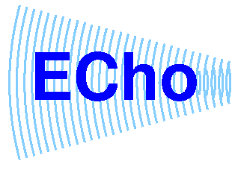
- Work with short phrases.

- PAUSE. Don’t jump in too soon.

- As you pause, listen to the “echo” in your head.

- Imitate the “echo” you hear; don’t automatically use the pronunciation you’re accustomed to.

- Get feedback; at first it may be uncomfortable, but it’s what helps
us improve and grow. Note facial expressions of your listener.
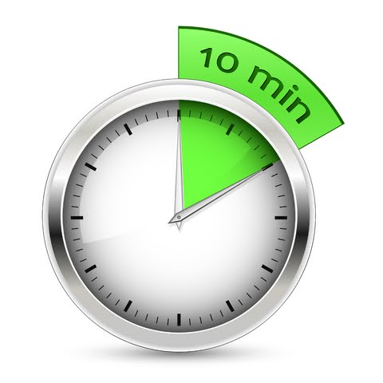

- Daily practice: listening, imitating, reading aloud.
10 MINUTES A DAY! One phrase at a time,
about 5-7 words: Listen-Echo-Repeat. Listen-Echo-Repeat.

- After you can repeat the phrase after the 1. Echo (Listen-Echo-Repeat) without thinking much, move on to 2. Listen-and-Repeat 跟著唸several times; then 3. Simultaneous 同步reading or reciting along with the audio.

- Mistakes are treasures – they show us how language works and how to adjust our teaching.

Practice with TV Series, like The Big Bang Theory
Go over the script carefully, one scene at a time.
Look up all the words, phrases and cultural allusions you're not sure of.
Make sure each line makes sense! If it doesn't, Google it!
Next, go back and do Echo practice.

Text-to-Speech
How to have Alex read to you on an Apple device:
https://support.apple.com/zh-tw/HT203077

Android: Google Play Google Text-to-Speech
https://play.google.com/store/apps/details?id=com.google.android.tts

Chrome Extension: Read Aloud
https://chrome.google.com/webstore/detail/read-aloud-a-text-to-spee/hdhinadidafjejdhmfkjgnolgimiaplp?hl=en

Additional resources here: http://homepage.ntu.edu.tw/~karchung/30/30Tricks.htm

http://68.media.tumblr.com/fec1095aa634aa92868bd49a4cfc736e/tumblr_inline_mulkb0Rnc91rplshr.png

