CET Pronunciation Workshops 2019
Stop at Stops!
Karen Chung 史嘉琳
台大外文系 副教授
English questions answered free on: Karen on Ivy League Analytical English on
https://www.facebook.com/Karen-on-Ivy-League-Analytical-English-234235001756/timeline/
Series of articles in Chinese on English learning and pronunciation in CET’s HellO! E.T:
http://homepage.ntu.edu.tw/~karchung/Karen/Karen_Chung_publications.htm#CET
Online Phonetics Course 語音學on NTU Open Course Ware 台大開放式課程page:
http://ocw.aca.ntu.edu.tw/ntu-ocw/index.php/ocw/cou/101S102
Subscribe to Email updates: http://eepurl.com/505qT
Stop at stops! articles:
1. 大師開講 — Stop at stops! —— 遇到塞音請停！ in No. 75, January/February 2013, p. 12-14. http://homepage.ntu.edu.tw/~karchung/pubs/CET75.pdf

2. 英語島：連音塞音篇：STOP at STOPS! 遇到塞音請暫停！
November 2018 http://www.eisland.com.tw/Main.php?stat=a_AW7p8hN&mid=36

More articles on linking:
3. 英語島：連音：英語「字裡行間」的玄機 - 母音篇
July 2018 http://www.eisland.com.tw/Main.php?stat=a_AO4wy0h&mid=36
4. 英語島： 連音鼻音篇：如何避免“N”G英文？
September 2018 http://www.eisland.com.tw/Main.php?stat=a_uNfRMMN&mid=36
5. 英語島：連音"y"字篇：「醬子」講哪裡不對？
October 2018 http://www.eisland.com.tw/Main.php?stat=a_uNfRMMN&mid=36

A. What are “stops” 塞音?
1. voiceless stops 無聲塞音: /p/ /t/ /k/
2. voiced stops 有聲塞音: /b/ /d/ /g/
3. special voiceless stop: the glottal stop 喉塞音: /ʔ/
Sounds like a basketball just hit your stomach: 「呃！」(but with no vowel).

B. Stops are not usually a problem for Chinese speakers at the beginning of words, where
/p/ /t/ /k/and /b/ /d/ /g/are quite similar to: ㄆ ㄊ ㄎ and ㄅ ㄉ ㄍ:
/p/ pan ㄆ 潘
/b/ ban ㄅ 般

/t/ ting ㄊ 聽
/d/ding ㄉ 丁

/k/ cut ㄎ 科
/g/ gut ㄍ 歌

Note: /b/ /d/ /g/ are voiced (like 米 and 拉 in Taiwanese), while ㄅ ㄉ ㄍ are voiceless, not voiced.

However, at the beginning of a sentence or phrase, /b/ /d/ /g/are usually voiceless, just like ㄅ ㄉ ㄍ.
(That’s a rule that usually doesn’t get taught in English classes in Taiwan!)

C. Stops are often a problem at the end of an English word or syllable:

tap keep lip type cab rib rub lab
cut right not put food sad did red
pick like make take dig rug log tag

Especially when there is another word right after them.

You do need to pronounce the final stops, regardless of what you think you’ve heard native speakers in movies do when speaking fast! They do pronounce pretty much ALL final stops!

Minimal pair practice
/-p/ vs. /-b/

rope robe
cup cub
cap cab
rip rib
lap lab
nip nib
pup pub

/-t/ vs. /-d/
bat bad
got god
hat had
write ride
ant and
at add
bet bed
cart card
eight aid
feet feed
heart hard
hit hid
hurt heard
mat mad
meant mend
neat need
not nod
plate played
sat sad
sent send
set said
sheet she’d
sight side
spent spend
state stayed
wait weighed

beat bead
bent bend
bright bride
but bud
cat cad
cute queued
debt dead
fat fad
heat heed
height hide
hot hod
kit kid
meet mead
oat owed
pat pad
port poured
pot pod
quit quid
route rude
short shored
slight slide
sought sawed
tent tend
tight tied
bleat bleed
cot cod
fate fade
float flowed
font fond
gloat glowed
it id
moat mode
mount mound
plot plod
site sighed
slit slid
spite spied
stunt stunned
tint tinned
blurt blurred
clot clod
faint feigned
goat goad
grit grid
naught gnawed
pant panned
pert purred
plaint planed
pleat plead
punt punned
scant scanned
shunt shunned
skit skid
spurt spurred
tart tarred
trot trod

/-k/ vs. /-g/

back bag

pick pig
clock clog
dock dog
duck dug
frock frog
muck mug

black blag
block blog
brick brig
broke brogue
buck bug
crack crag
dick dig
jock jog
lack lag
leak league
lock log
luck lug
pluck plug
rack rag
ruck rug
sack sag
smock smog
snack snag
tack tag

beck beg
chuck chug
flock flog
hack hag
jack jag
knack nag
puck pug
slack slag
snuck snug
stack stag
tuck tug
whack wag
wick wig

https://www.englishclub.com/pronunciation/minimal-pairs-t-d.htm
D. Paying attention to final stops

There are different ways of dealing with final stops, depending on the sound that comes next!

But first, you need to care! That’s means paying attention to /p/ /t/ /k/and /b/ /d/ /g/
at the end of every word and syllable. DON’T ignore them!

E. Watching out for final stops: /p/ /t/ /k/and /b/ /d/ /g/
1. LINKING (next sound is a vowel):

For final consonants:
First, draw a circle or rectangle around every /p/ /t/ /k/and /b/ /d/ /g/
that occurs at the end of a syllable.
Second, if the next syllable or word starts with a vowel:
Draw a linking mark from the consonant to the vowel,
e.g. kind of → kind‿of big as → big‿as
This also applies to other sounds that are not stops, so add linking marks to these words too.

For other final consonants:
e.g. eyes of → eyes‿of am I → am‿I

For final vowels:
For vowels with a final /i/or /ɪ/ sound, add a little raised ^{j};
e.g. see in → see ^{j}in they are → they^{j}are

For vowels with a final /u/ or /ʊ/ sound, add a little raised ^{w}:
e.g. do it → do^{w}it so is → so^{w}is

2. STOPPING AT STOPS (the next sound is a consonant)
If the next word or syllable starts with a consonant, then you need to
STOP at the STOP and PAUSE a bit before reading the next sound!

Examples:

tap fast keep right lip stick type cast cab door rib cage rub down lab coat
cut down right now not now put down food tax sad face did more red light
pick cars like them make time take care dig deep rug yarn log pile tag word

Practice Texts
Text 1:
Do you want to see in the dark? This might be possible. Scientists gave mice the ability to see near-infrared light. This is a kind of light that mice cannot usually see. Researchers from universities in China and the USA changed the vision of the mice they tested. They injected special nanoparticles into their eyes. These nanoparticles let the mice see better in the dark. The injections meant the mice could see in the dark for about 10 weeks. The scientists said the injections did not damage the eyesight of the mice. The eyes of the mice did not suffer from any side effects.

The research is published in the journal 'Cell'. The researchers hope their tests could be done on humans. Researcher Dr Tian Xue said: "Human beings have been trying to develop new technology to enable abilities that are beyond our natural abilities." He said tests in the future could let humans see in the dark. Dr Tian added: "Another cool thing about this potential technology is that it wouldn't require a person to wear heavy and energy-intensive equipment, such as night-vision goggles." He also said the military might be interested in his research.
https://breakingnewsenglish.com/1903/190306-night-vision-2.html

Text 2:
More companies around the world are letting staff not wear a suit and tie. In the past, most business people and office workers had to wear business clothes. Today, this is becoming less important. Companies want their workers to dress more casually. Staff will feel more relaxed and work harder. The latest international company to relax its dress code is the investment bank Goldman Sachs. It asked its workers to "exercise good judgment" in deciding what to wear. It said the change was due to "the changing nature of workplaces generally in favor of a more casual environment".

Some business people think more casual dress is not good. The founder of the investment company 7IM said not wearing a suit could give a bad image to clients. He said: "You're looking after people's money, so you should behave and dress respectfully. I would not expect to hand over my pension to someone in jeans....It may be old-fashioned but I think it would be dangerous for a business to do that." He added: "If you let people dress sloppily, that is how your brand will be perceived." Companies like Google let staff dress casually and wear jeans and T-shirts to the office.
https://breakingnewsenglish.com/1903/190322-business-suit-2.html

Text 3:
Japan is changing because it needs workers. It is an aging society. This means it does not have enough workers. Japan's government has decided to employ workers from other countries to fill jobs. Japan's Prime Minister Shinzo Abe said his government will meet to approve a plan, which could become law on April 1. The new law would allow up to 345,000 foreign workers to help with its shortage of labor. Many of these will work in construction, fishing, healthcare and agriculture. They will be mainly low-skilled workers and need to pass a Japanese language test.

Japan's government said on Saturday that it had to change and let more foreign workers in to help the economy. It said: "If Japan simply continued along the same path, we would find ourselves in a very difficult situation." The government will make sure foreign workers can quickly adjust to life in cities and towns. It said: "We want to ensure they have the right environment in which to live and work." Japanese people are having fewer children - only 1.4 children per woman. This should be 2.1 for Japan to have enough workers. Japan's population is already dropping every year.
https://breakingnewsenglish.com/1812/181211-foreign-workers-2.html

Text 4:
New technology is reducing children's ability to use a pencil. Researchers from the UK's health service said that children spend so much time swiping iPads or mobile phone screens that they cannot hold a pencil properly. This means their hands do not have the muscle strength to be able to write properly. Researcher Dr Sally Payne said: "Children are not coming into school with the hand strength...they had 10 years ago. Children coming into school are being given a pencil but are increasingly not able to hold it because they don't have the...skills."

Technology is changing the way that children write, draw or make things. Children are now using technology to create. Dr Payne explained that: "It's easier to give a child an iPad than encourage them to do muscle-building play such as building blocks, cutting and sticking, or pulling toys and ropes [so] they're not developing the...skills they need to grip and hold a pencil." Some experts say technology is causing bigger problems. One expert said if a child isn't strong enough to hold a pencil, perhaps their whole body is weak. She said children needed to climb trees instead.
https://breakingnewsenglish.com/1804/180404-pencils-2.html

Short dialogue practice: TV Repair Person

(A picks up phone and calls repair shop)
A: Hello, TV repair? Can you send someone over? Oh, good thank you.
B. (knocks on door) Handy Dandy TV Repair, at your service.
A: Oh, do come in. The TV is over there.
B: What seems to be the problem?
A: Well, I turn it on, but I don't get anything. No picture, no sound, nothing.
B. Sounds serious. Let me have a look. (begins to pull things out of TV and throw them aside)
A: Oh, dear! (moans while watching repairperson take TV apart)
B. Well, it's not that, and it's not this…Well, I think I’ve found the problem.
A. The picture tube, right?
B. No!
A. The sound tube then?
B. No!
A. (irritated) Well, then, what is it?
B. You haven't got it plugged in!
A. The plug! Oh no!
B. That'll be $87 for the house call.
A. What? I'll $87 you! (grabs repair person by collar and leads him/her to door.)
http://www.timelessteacherstuff.com/readerstheater/TVRepairPerson.pdf

The trick I will use to remind myself to “stop at stops” when I read and speak:
______________________________________________________________
______________________________________________________________
______________________________________________________________
______________________________________________________________
______________________________________________________________
______________________________________________________________

From previous workshops:
Step 1. Phrasing 斷句:

Always think of your LISTENER when speaking and reading!
Taiwanese tend to race to the finish when reading, with almost no pauses, making it difficult for listeners to understand. The reader will also not usually understand what they’re reading, and they will sound stressed and nervous. Conscious learning of where to pause can fix this!

Read through the texts above, | marking shorter pauses | (e.g. marked by a comma, | or no punctuation) | with |, and longer ones | (e.g. marked by a semi-colon or period) | with || in (1)-(4). ||

Pause:
- After the complete subject 完整的主詞前
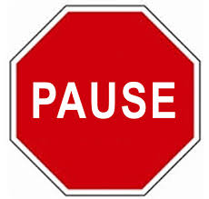
- Before “that” and other clauses “that” 等子句前
- At most punctuation marks 遇到標點符號時
- Before conjunctions 連接詞前
- Before prepositions 介系詞前
- Parentheticals 插入語 (e.g. Ted, unfortunately, couldn’t come.)
Step 2. Mark intonational stress
Three Basic Rules of Intonation:
1. Stress content words
(nouns, verbs, adjectives, some adverbs);
don’t stress function words
(articles, conjunctions, prepositions, pronouns,
helping verbs, “be” verbs, some adverbs).
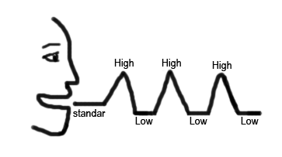
2. Stress new information; don’t stress old information.
3. Stress contrasted words; everything else is unstressed
(a low, flat tone).

DON’T stress the syllables you shouldn’t!
Remember that English stress is usually marked by a higher pitch;
unstressed syllables are often read in a string with a low, even pitch,
much like an extended Mandarin third tone, e.g. She wasn’t even thinking about you | when she *did it.

— — — – — THINK _ _ __ _/ | — — *DID _

Underline all stressed syllables in (1)-(4).

Step 3. Mark *tonic stress:
The last stressed *syllable in every phrase or *thought group gets an especially high (or low) into*national stress. This is called *tonic stress. We’ll mark it with an *asterisk.
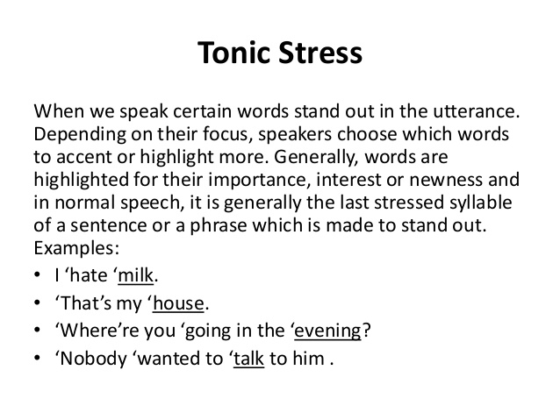

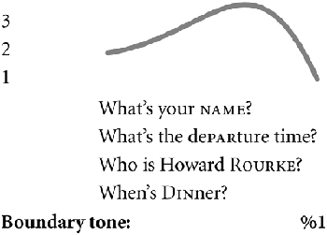
Step 4. Mark final falling and rising intonations
If you’re at the end of a complete idea or sentence –
usually marked with a period . or semi-colon ; , use a falling intonation.
Wh- questions (asked with who, what, where, when, why, how, which,
and how) also have a falling intonation. Mark with a high-falling line.
Mark yes-no questions with a rising intonation. All clear?
Step 5. Mark all of the continuation rises ʅ, both large and small
Taiwanese students tend to have a falling intonation at the end of all phrases.
But there should be a rise at the end of most phrases that aren’t the end of a sentence.
ʅ
The highest point is the tonic stress,
then it drops down low, and then there’s a gentle rise.

Practice using the continuation rise where called for.
Mark all of the continua tion rises with a line as indicated.

Mark the continuation rise over the following intonational chunks of one to six syllables:

…with my friend, …
…with my mother, …
…with a relative, …
…with a relative there, …
…with a relative of mine, …
…with a relative I don’t know…

Step 6. Circle in red all of the vowels pronounced /eɪ/
Be careful to pronounce them as ㄟㄧ, NOT as /ɛ/ or /æ/.
Be especially careful when /eɪ/ comes before a nasal consonant,
i.e. /eɪn/ and /eɪm/, as in sane /seɪn/ and same /seɪm/.

Step 7. /ɑ/ and /ɔ/
A single vowel letter “o” (not “oa” or “o” + silent “e”)
is often pronounced as /ɑ/ ㄚ in American English,
e.g. hot /hɑt/ and Tom /tɑm/ – watch out for it!

/ɔ/ as in “law”, “caught” and “gone” is a long vowel
that sounds a little like Southern Min 芋仔 read as one syllable instead of two. Write /ɑ/ or /ɔ/ above any vowel you need a reminder for.
Step 8. /s/ vs. /z/: Draw a wavy underline under all letter “s”s that are pronounced /z/

Watch your “s”s – some should be pronounced /z/, as in lose, raise, days, and diseases!

Step 9. Compound Noun Stress

In compound nouns, i.e. noun + noun expressions, only the stressed syllable of the modifying noun is stressed. Adjective + noun expressions with special meanings are stressed in this way too. These expressions are stressed as though they were one word.
Examples: con*venience store, *peanut butter, *exercise bike, *newspaper, *girlfriend, *boyfriend, *bookshelf, com*puter desk, *airplane, in*surance salesman, *car door;
*hot dog, *greenhouse, *blackboard

Step 10. Watch out for the pronunciations of these common words and mark if needed:

of [ʌv] or [əv], as [æz], because [bi ‘kʌz], she [ʃi] (NOTㄒㄩ),
says [sɛz] (not [sez] or [seɪz]), said [sɛd] (not [sed] or [seɪd]), ask, asks, asked.
Step 11. Voicing affects vowel length

If the final sound of a syllable is voiced, the vowel that precedes it must be lengthened. Contrast the following: cap/cab [kæp]/[kæːb] lit/lid [lɪt]/[lɪːd] duck/dug [dʌk]/[dʌːg]
lap/lab; mop/mob; pup/pub; cop/cob; rope/robe; bit/bid; pat/pad; sit/Sid; set/said; mutt/mud
Step 12. Mark linking

When a word starts with a vowel, link the last sound of the preceding word to it, and read the two
as though they are one word, e.g.: when I [wɛ ̬naɪ], people are ['pipə ̬lɑr].

Step 13. Watch out for schwas [ə], i.e. the reduced vowel in some unstressed syllables

Schwas are often found in unstressed syllables, e.g. conceited /kən'sitəd/, and in function words like to, of, or, in; don’t read them as full vowels!

ə ə ə
Add a schwa symbol [ə] over unstressed, reduced vowels.
Step 14. The “tap”
In US English, when a “t” that comes between two vowels, and the syllable to the right is unstressed, the “t” is pronounced like a very short /d/, and is called a “tap” or “flap”. The symbol is [ɾ].
ɾ
Write a “tap” symbol ɾ above “t”s that should be pronounced as “taps”.

Step 15. Remember your “r”s!

Taiwanese often omit “r” sounds after vowels, e.g. in farm, large. Don’t! Almost ALL “r”s are pronounced in US English! Make them a strong, Beijing-style ㄦ sound!
√ √
Add a check √ above each “r” following a vowel if you tend to forget them.

More:
- How you sound to others before working hard on your pronunciation:
https://www.youtube.com/watch?v=w8MlL2GhhOw&t=43s

Poor pronunciation…
• affects understanding
• makes other people tired as they struggle to understand you
• makes others think you are less intelligent than you are
• will affect your social life

What can happen if you're sloppy about your vowels:
你有沒有不小心講出「限制級英文」? http://www.eisland.com.tw/Main.php?stat=a_0GECDzr&mid=36
- Priorities, commitment, new HABIT formation
One Small Step Can Change Your Life animated by Nathan Lozeron
Also: How to Build Habits & Execute Effortlessly https://www.youtube.com/watch?v=w8MlL2GhhOw
https://www.youtube.com/watch?v=-LdhudFvJuE 1-page pdf
Ask yourself:  - Do I really want to improve my English?  - How high a priority is it for me?  - If it is a high priority, then I will find a time  to work on my English DAILY.  Take baby steps! But do it EVERY DAY!  Make it AUTOMATIC! | 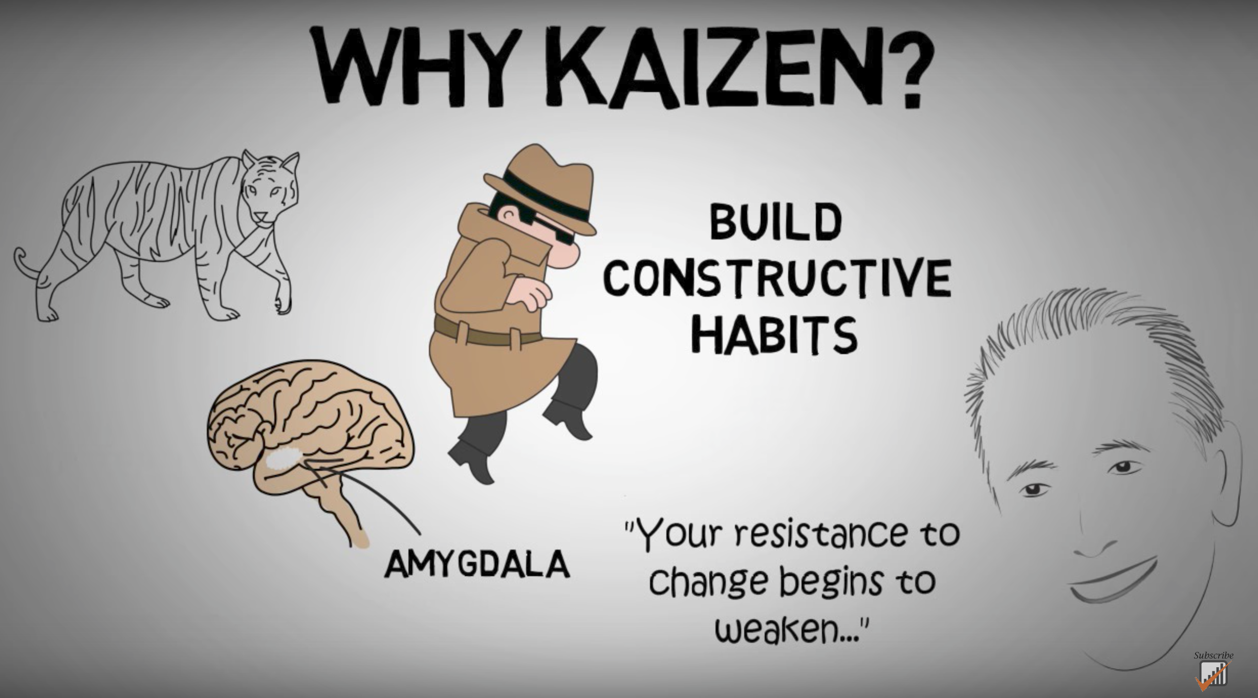  https://www.youtube.com/watch?v=VHkOFs67d9A
When, where, what?
- I will work on my English for 10-15 minutes starting from _____:_____ am / pm EVERY DAY.
- I will work on my English here: ___________________________.
- I will practice with these materials: __________________________________.
(TV show/movie/podcast/audio file)

Don’t beat yourself up if you miss a day, but DON’T QUIT! Get back to it tomorrow!

- Phonics
Phonics is most useful for people who already speak English,
and in addition, only a FEW phonics rules are truly useful;
for rules beyond these, there are many exceptions.
So in most cases it’s better to either use IPA or – much better –
to listen to the correct pronunciation in an AUDIO DICTIONARY,
like The Free Dictionary
http://www.thefreedictionary.com/

US citation forms: the lower speaker icon;
colloquial pronunciations: upper left hand speaker icon;
standard British English pronunciation: upper right hand speaker icon.
Listen to words and phrase in context on http://youglish.com/

- English consonants

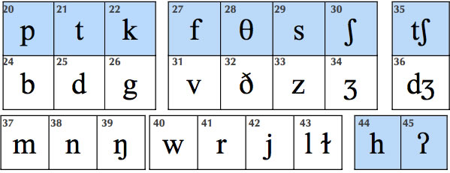
- English Vowels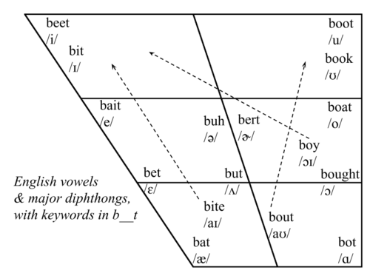

Vowel | Description | Example
 | forward vowel | as in beet
 | forward vowel | as in bit
 | diphthong | as in bait
 | forward vowel | as in bet
 | diphthong | as in bat
 | diphthong | as in by
 | diphthong | as in house
 | back vowel | as in boot
 | diphthong | as in abuse
 | back vowel | as in book
 | diphthong | as in boat
 | back vowel | as in awe
 | diphthong | as in boy
 | back vowel | as in father
 | central vowel, stressed | as in bud
 | central vowel, unstressed (schwa) | as in appeal
 | central vowel with r, stressed | as in burr
 | central vowel with r, unstressed (hooked schwa) | as in butter

- Good pronunciation requires good listening: The Echo Method

- Listen carefully to a good model. Good listening habits are the basis of good pronunciation. Practice active listening.
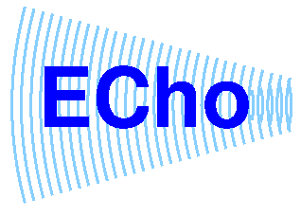
- Work with short phrases.

- PAUSE. Don’t jump in too soon.

- As you pause, listen to the “echo” in your head.

- Imitate the “echo” you hear; don’t automatically use the pronunciation you’re accustomed to.

- Get feedback; at first it may be uncomfortable, but it’s what helps
us improve and grow. Note facial expressions of your listener.
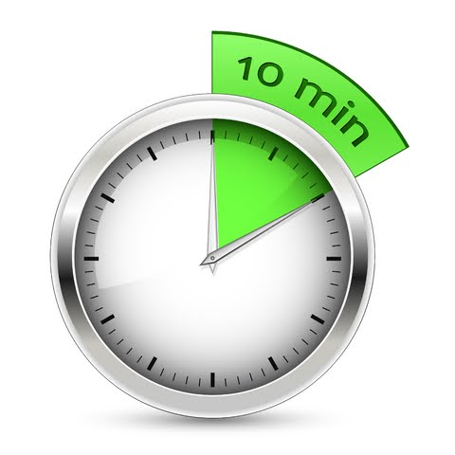

- Daily practice: listening, imitating, reading aloud.
10 MINUTES A DAY! One phrase at a time,
about 5-7 words: Listen-Echo-Repeat. Listen-Echo-Repeat.

- After you can repeat the phrase after the 1. Echo (Listen-Echo-Repeat) without thinking much, move on to 2. Listen-and-Repeat 跟著唸several times; then 3. Simultaneous 同步reading or reciting along with the audio.

- Mistakes are treasures – they show us how language works and how to adjust our teaching.

- Practice with TV Series, like The Big Bang Theory
Go over the script carefully, one scene at a time.
Look up all the words, phrases and cultural allusions you're not sure of.
Make sure each line makes sense! If it doesn't, Google it!
Next, go back and do Echo practice.

Additional resources here: http://homepage.ntu.edu.tw/~karchung/30/30Tricks.htm

http://www.anenglishaccent.com/Images/consonants.jpg
http://68.media.tumblr.com/fec1095aa634aa92868bd49a4cfc736e/tumblr_inline_mulkb0Rnc91rplshr.png
http://cmed.faculty.ku.edu/ipafolder/vowels.html

