 | 無尾熊
2014/6/30
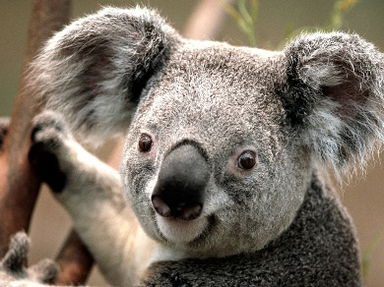 | 台北市復興南路二段1樓  0933-123-456  coala@yahoo.com.tw

應徵職位
業務助理
教育
台灣大學
2014 年 7 月
台灣大學資訊系學士
經驗
工讀生 | 幸福補習班
2009 - 2011
負責協助電話招生業務、資料整理
行政助理 | 快樂商行
2011 - 2013
負責商品的排列、接洽
自傳
I am 24 years old. My father works in a bank and my mother is a housewife. I am the only child in the family. My parents make very sure of that by training me to be independent. I am interested in computer since I was in the fifth grade of elementary school. My friends know I am good at computer, so once there computers have some problems, they will come to me.
我今年 24 歲。父親在一家銀行工作，母親是家庭主婦。我是家中的獨生女，正因為怕我變得嬌縱，父母從小就訓練我要獨立。從國小五年級就開始對電腦感興趣，朋友知道我對電腦很在行，只要電腦有問題，都會找我幫忙。

