Problem 1

Number equations consecutively with equation numbers in parentheses flush with the right margin, as in (1). First use the equation editor to create the equation. Then select the “Equation” markup style. Press the tab key and write the equation number in parentheses. To make your equations more compact, you may use the solidus ( / ), the exp function, or appropriate exponents. Use parentheses to avoid ambiguities in denominators. Punctuate equations when they are part of a sentence, as follows:

(1)

Be sure that the symbols in your equation have been defined before the equation appears or immediately following.

Problem 2

No matter how you convert your images, it is a good idea to print the TIFF files to make sure nothing was lost in the conversion as shown in Figure 2-1 and Figure 2-2.

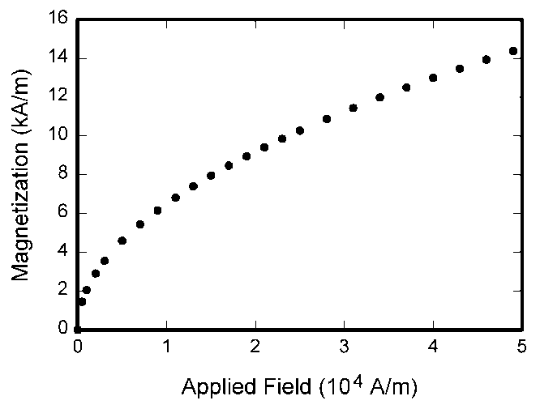
(a) | (b)
(c)
Figure 2-1. Magnetization as a function of applied field. (a) Note that “Fig.” is abbreviated. (b) There is a period after the figure number, followed by two spaces. (c) It is good practice to explain the significance of the figure in the caption.

Problem 3

In this section, simulations as well as real-world experiments are conducted to demonstrate and analyze the results of the proposed methods. An introduction to the hardware platforms and the software platforms under which the simulations and the experiments performs are conducted is given.

TABLE I
Units for Magnetic Properties
Symbol | Quantity | Conversion from Gaussian and  CGS EMU to SI ª
Φ | magnetic flux | 1 Mx → 10⁻⁸ Wb = 10⁻⁸ V·s
m | magnetic moment | 1 erg/G = 1 emu  → 10⁻³ A·m² = 10⁻³ J/T
μ_{r} | relative permeability | μ → μ_{r}
w, W | energy density | 1 erg/cm³ → 10⁻¹ J/m³
N, D | demagnetizing factor | 1 → 1/(4π)
.

References

[1: Stankovic 2002]
Srdjan S. Stankovic, “Decentralized Overlapping Control of a Platoon of Vehicles,” IEEE Transactions on Control Systems Technology, Vol. 8, No. 5, pp. 816-832, Sep. 2002

[2: Bello & Mirabella 2000]
Larry L. Bello and Olamda Mirabella, “Analysis and Comparison of Different Interconnection Solutions for Switched Ethernet Networks,” in Proceedings of IEEE International Workshop on Factory Communication Systems, Porto, Portugal, pp. 221-230, Sep. 6-8, 2000

[3: Aweya et al. 2002]
Jack Aweya, Micheal Ouellette, Jerry M. Korsakas, and David Y. Montuno, “Inter-Working of Switched Ethernet and ATM Flow Control Mechanisms,” International Journal of Network Management, Vol. 12, No. 6, pp. 357-366, May 2002

