CET Pronunciation Workshops 2018
Learning to Sing the Melody of English
Karen Chung 史嘉琳
台大外文系 副教授
English questions answered free on: Karen on Ivy League Analytical English on
https://www.facebook.com/Karen-on-Ivy-League-Analytical-English-234235001756/timeline/
Series of articles in Chinese on English learning and pronunciation in CET’s HellO! E.T:
http://homepage.ntu.edu.tw/~karchung/Karen/Karen_Chung_publications.htm#CET
Online Phonetics Course 語音學on NTU Open Course Ware 台大開放式課程page:
http://ocw.aca.ntu.edu.tw/ntu-ocw/index.php/ocw/cou/101S102
Subscribe to Email updates: http://eepurl.com/505qT
Speech as music: Listen for the beat and melody
Stress is the drumbeat that marks the rhythm of *English
- Willy Wonka with Drums
https://www.youtube.com/watch?v=INt4GGr-EGU
GRANDPA JOE: Mr. Wonka?

WONKA: I am extraordinarily busy, sir.
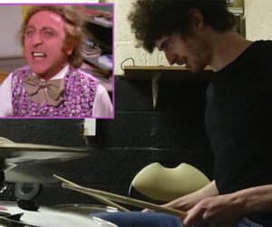
GRANDPA JOE: I just wanted to ask about the chocolate.
The lifetime supply of chocolate, for Charlie. When does he get it?

WONKA: He doesn't.

GRANDPA JOE: Why not?

WONKA: Because he broke the rules.

GRANDPA JOE: What rules? We didn't see any rules, did we,
Charlie?

WONKA: Wrong, sir, wrong! Under Section Thirty-Seven B of
the contract signed by him it states quite clearly that all
offers shall become null and void if – and you can read it
for yourself in this photostatic copy: "I, the undersigned,
shall forfeit all rights, privileges, and licenses herein
and herein contained, et cetera, et cetera . . . fax mentis
incendium gloria culpum, et cetera, et cetera . . . memo bis
punitor delicatum!" It's all there, black and white, clear
as crystal! You stole Fizzy Lifting Drinks. You bumped
into the ceiling which now has to be washed and sterilized,
so you get nothing! You lose! Good day, sir!

GRANDPA JOE: You're a crook! You're a cheat and a swindler!
That's what you are. How can you do a thing like this?
Build up a little boy's hopes and then smash all his dreams
to pieces. You're an inhuman monster!

WONKA: I said Good Day!

- Listen to the pitch line of two famous sentences played on a piano:
http://homepage.ntu.edu.tw/~karchung/CETPron2018/20Khertzmusicofvoicewhoisthis.mp3
What is being said? Who is saying it?
Note that, similar to speech, music is divided into measures 小節 (“bars” in British English).
- Text mark-up and reading practice
A Lesson From My Dad
by Mary Beth M.
MP3 file: http://homepage.ntu.edu.tw/~karchung/Audacity%20files/ALessonFromMyDad.mp3
1. My dad, Big Jim, was a far-from-perfect specimen. But he was Daddy and I was Daddy’s Girl and I loved him, flaws and all.

2. One day, I came home from school all upset because someone had hurt my feelings. I recounted the story to Daddy, expecting an outpouring of sympathy against this wrongdoing.

3. “Mary Elizabeth, I’m ashamed of you,” Daddy surprised me by saying. “How can you be so conceited?”

4. Conceited? Me? Good grief, I was the injured party here, not the culprit. I was in shock.

5. “For you to think this girl did this to you on purpose is very conceited,” he continued. “Chances are she wasn’t even thinking about you when she did it. Most people are more concerned with what they want than they are with hurting someone else. To deliberately hurt someone takes effort, and most people don’t even think of others as worth the effort.”

6. I had to think about that one a bit. I remembered all the times I said “I didn’t mean to” when one of my three younger sisters thought I was out to get them, and I had to agree with him. When they charged “Foul,” I usually wasn’t even thinking about them. Maybe he had a point.

7. “Don’t ever get the idea you’re more important than anyone else,” he warned. “You are no better than anybody out there.”

8. Well, no problem there. I didn’t think that I thought I was more important than anyone else. But he wasn’t finished.

9. “No, you’re no better than anyone else around, but by God, you are every bit as good as everybody else!”

10. Thanks to the lesson Daddy gave me that day, I’ve been able to shrug off a lot of petty incidents as nothing, when I could have been tempted to make them a huge deal. I’d guess a lot of relationships are much smoother for me because of Daddy’s advice. Although he’s been gone more than thirty years, he’s still helping me. I guess that’s one of the benefits of being Daddy’s Girl!

Step 1. Phrasing 斷句:

Always think of your LISTENER when speaking and reading!
1. How does this sound to you?
http://homepage.ntu.edu.tw/~karchung/CETPron2018/crow1.mp3

2. Is this a bit better?
http://homepage.ntu.edu.tw/~karchung/CETPron2018/crow2.mp3

3. Let’s try it with English:
http://homepage.ntu.edu.tw/~karchung/CETPron2018/crowE3.mp3
4. Is this more comfortable to follow and easier to understand?
http://homepage.ntu.edu.tw/~karchung/CETPron2018/crowE4.mp3
Taiwanese tend to race to the finish when reading, with almost no pauses, making it difficult for listeners to understand. The reader will also not usually understand what they’re reading, and they will sound stressed and nervous. Conscious learning of where to pause can fix this!

Read through the short story above, | marking shorter pauses | (e.g. marked by a comma, | or no punctuation) | with |, and longer ones | (e.g. marked by a semi-colon or period) | with || in (1)-(4). ||

Pause:
- After the complete subject 完整的主詞後
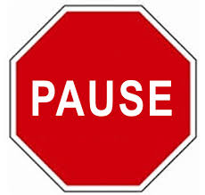
- Before “that” and other clauses “that” 等子句前
- At most punctuation marks 遇到標點符號時
- Before conjunctions 連接詞前
- Before prepositions 介系詞前
- Parentheticals 插入語 (e.g. Ted, unfortunately, couldn’t come.)

Step 2. Mark intonational stress
Three Basic Rules of Intonation:
1. Stress content words
(nouns, verbs, adjectives, some adverbs);
don’t stress function words
(articles, conjunctions, prepositions, pronouns,
helping verbs, “be” verbs, some adverbs).
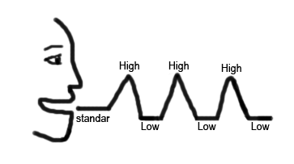
2. Stress new information; don’t stress old information.
3. Stress contrasted words; everything else is unstressed
(a low, flat tone).

DON’T stress the syllables you shouldn’t!
Remember that English stress is usually marked by a higher pitch;
unstressed syllables are often read in a string with a low, even pitch,
much like an extended Mandarin third tone, e.g. she wasn’t even thinking about you | when she *did it.

— — — – — THINK _ _ __ _/ | — — *DID _

Underline all stressed syllables in (1)-*(4).

Step 3. Mark *tonic stress:
The last stressed *syllable in every phrase or *thought group gets an especially high (or low) into*national stress. This is called *tonic stress. We’ll mark it with an *asterisk.
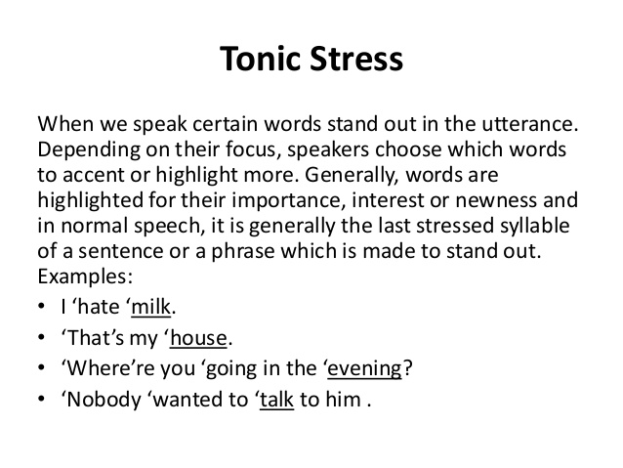

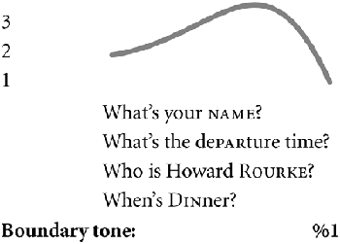
Step 4. Mark final falling and rising intonations
If you’re at the end of a complete idea or sentence –
usually marked with a period . or semi-colon ; , use a falling intonation.
Wh- questions (asked with who, what, where, when, why, how, and which) also have a falling intonation. Mark with a high-falling line.
Mark yes-no questions with a rising intonation. All clear?
Step 5. Mark all of the continuation rises ʅ, both large and small
Taiwanese students tend to have a falling intonation at the end of all phrases.
But there should be a rise at the end of most phrases that aren’t the end of a sentence.
ʅ
The highest point is the tonic stress,
then it drops down low, and then there’s a gentle rise.

Practice using the continuation rise where called for.
Mark all of the continua tion rises with a line as indicated.

Mark the continuation rise over the following intonational chunks of one to six syllables:

…with my friend, …
…with my mother, …
…with a relative, …
…with a relative there, …
…with a relative of mine, …
…with a relative I don’t know…

Step 6. Circle in red all of the vowels pronounced /eɪ/
Be careful to pronounce them as ㄟㄧ, NOT as /ɛ/ or /æ/.
Be especially careful when /eɪ/ comes before a nasal consonant,
i.e. /eɪn/ and /eɪm/, as in sane /seɪn/ and same /seɪm/.

Step 7. /ɑ/ and /ɔ/
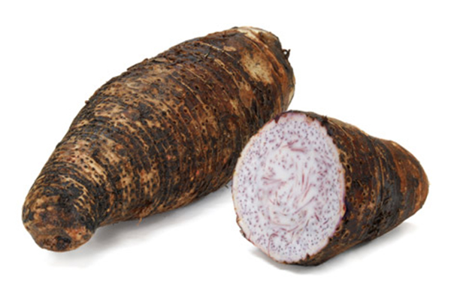
A single vowel letter “o” (not “oa” or “o” + silent “e”)
is often pronounced as /ɑ/ ㄚ in American English,
e.g. hot /hɑt/ and Tom /tɑm/ – watch out for it!

/ɔ/ as in “law”, “caught” and “gone” is a long vowel
that sounds a little like Southern Min 芋仔 read as one syllable instead of two. Write /ɑ/ or /ɔ/ above any vowel you need a reminder for.
Step 8. /s/ vs. /z/: Draw a wavy underline under all letter “s”s that are pronounced /z/

Watch your “s”s – some should be pronounced /z/, as in lose, raise, days, and diseases!

Step 9. Compound Noun Stress

In compound nouns, i.e. noun + noun expressions, only the stressed syllable of the modifying noun is stressed. Adjective + noun expressions with special meanings are stressed in this way too. These expressions are stressed as though they were one word.
Examples: con*venience store, *peanut butter, *exercise bike, *newspaper, *girlfriend, *boyfriend, *bookshelf, com*puter desk, *airplane, in*surance salesman, *car door;
*hot dog, *greenhouse, *blackboard

Step 10. Watch out for the pronunciations of these common words and mark if needed:

of [ʌv] or [əv], as [æz], because [bi ‘kʌz], she [ʃi] (NOTㄒㄩ),
says [sɛz] (not [sez] or [seɪz]), said [sɛd] (not [sed] or [seɪd]), ask, asks, asked.

Step 11. Voicing affects vowel length

If the final sound of a syllable is voiced, the vowel that precedes it must be lengthened. Contrast the following: cap/cab [kæp]/[kæːb] lit/lid [lɪt]/[lɪːd] duck/dug [dʌk]/[dʌːg]
lap/lab; mop/mob; pup/pub; cop/cob; rope/robe; bit/bid; pat/pad; sit/Sid; set/said; mutt/mud
Step 12. Mark linking

When a word starts with a vowel, link the last sound of the preceding word to it, and read the two
as though they are one word, e.g.: when I [wɛ ̬naɪ], people are ['pipə ̬lɑr].

Step 13. Watch out for schwas [ə], i.e. the reduced vowel in some unstressed syllables

Schwas are often found in unstressed syllables, e.g. conceited /kən'sitəd/, and in function words like to, of, or, in; don’t read them as full vowels!

ə ə ə
Add a schwa symbol [ə] over unstressed, reduced vowels.
Step 14. The “tap”
In US English, when a “t” that comes between two vowels, and the syllable to the right is unstressed, the “t” is pronounced like a very short /d/, and is called a “tap” or “flap”. The symbol is [ɾ].
ɾ
Write a “tap” symbol ɾ above “t”s that should be pronounced as “taps”.

Step 15. Remember your “r”s!

Taiwanese often omit “r” sounds after vowels, e.g. in farm, large. Don’t! Almost ALL “r”s are pronounced in US English! Make them a strong, Beijing-style ㄦ sound!
√ √
Add a check √ above each “r” following a vowel if you tend to forget them.

- How you sound to others before working hard on your pronunciation:
https://www.youtube.com/watch?v=w8MlL2GhhOw&t=43s

Poor pronunciation…
• affects understanding
• makes other people tired as they struggle to understand you
• makes others think you are less intelligent than you are
• will affect your social life
What can happen if you're sloppy about your vowels:
你有沒有不小心講出「限制級英文」? http://www.eisland.com.tw/Main.php?stat=a_0GECDzr&mid=36

- Priorities, commitment, new HABIT formation
One Small Step Can Change Your Life animated by Nathan Lozeron
Also: How to Build Habits & Execute Effortlessly https://www.youtube.com/watch?v=w8MlL2GhhOw
https://www.youtube.com/watch?v=-LdhudFvJuE 1-page pdf
Ask yourself:  - Do I really want to improve my English?  - How high a priority is it for me?  - If it is a high priority, then I will find a time  to work on my English DAILY.  Take baby steps! But do it EVERY DAY!  Make it AUTOMATIC! | 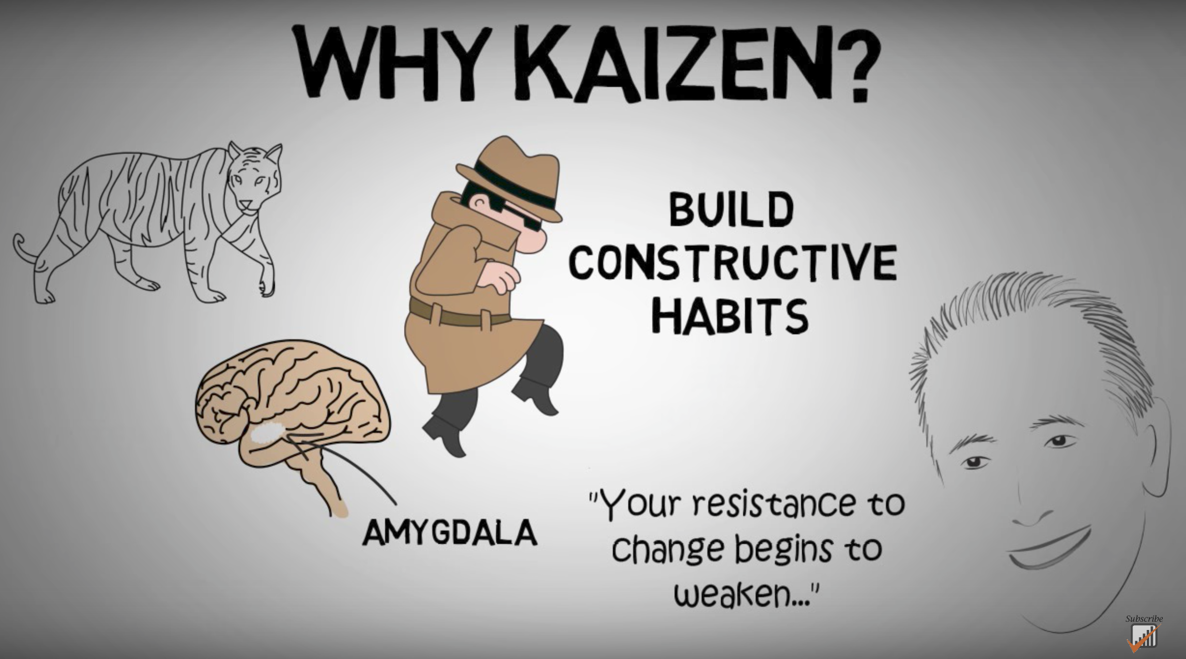  https://www.youtube.com/watch?v=VHkOFs67d9A
When, where, what?
- I will work on my English for 10-15 minutes starting from _____:_____ am / pm EVERY DAY.
- I will work on my English here: ___________________________.
- I will practice with these materials: __________________________________.
(TV show/movie/podcast/audio file)

Don’t beat yourself up if you miss a day, but DON’T QUIT! Get back to it tomorrow!

- Phonics
Phonics is most useful for people who already speak English,
and in addition, only a FEW phonics rules are truly useful;
for rules beyond these, there are many exceptions.
So in most cases it’s better to either use IPA or – much better –
to listen to the correct pronunciation in an AUDIO DICTIONARY,
like The Free Dictionary
http://www.thefreedictionary.com/
US citation forms: the lower speaker icon;
colloquial pronunciations: upper left hand speaker icon;
standard British English pronunciation: upper right hand speaker icon.
Listen to words and phrase in context on http://youglish.com/
- English consonants

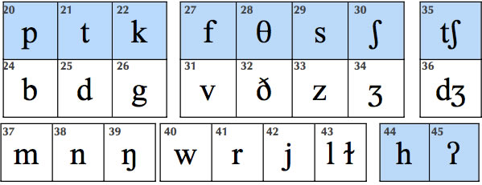
- English Vowels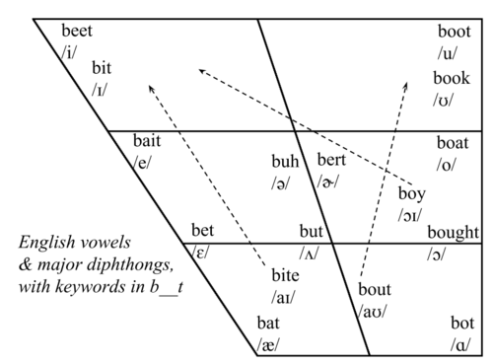

Vowel | Description | Example
 | forward vowel | as in beet
 | forward vowel | as in bit
 | diphthong | as in bait
 | forward vowel | as in bet
 | diphthong | as in bat
 | diphthong | as in by
 | diphthong | as in house
 | back vowel | as in boot
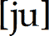 | diphthong | as in abuse
 | back vowel | as in book
 | diphthong | as in boat
 | back vowel | as in awe
 | diphthong | as in boy
 | back vowel | as in father
 | central vowel, stressed | as in bud
 | central vowel, unstressed (schwa) | as in appeal
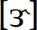 | central vowel with r, stressed | as in burr
 | central vowel with r, unstressed (hooked schwa) | as in butter

- Good pronunciation requires good listening: The Echo Method

- Listen carefully to a good model. Good listening habits are the basis of good pronunciation. Practice active listening.
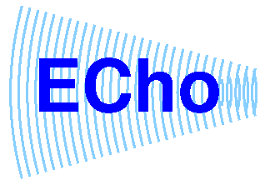
- Work with short phrases.

- PAUSE. Don’t jump in too soon.

- As you pause, listen to the “echo” in your head.

- Imitate the “echo” you hear; don’t automatically use the pronunciation you’re accustomed to.

- Get feedback; at first it may be uncomfortable, but it’s what helps
us improve and grow. Note facial expressions of your listener.
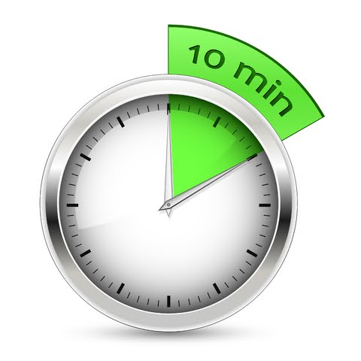

- Daily practice: listening, imitating, reading aloud.
10 MINUTES A DAY! One phrase at a time,
about 5-7 words: Listen-Echo-Repeat. Listen-Echo-Repeat.

- After you can repeat the phrase after the 1. Echo (Listen-Echo-Repeat) without thinking much, move on to 2. Listen-and-Repeat 跟著唸several times; then 3. Simultaneous 同步reading or reciting along with the audio.

- Mistakes are treasures – they show us how language works and how to adjust our teaching.

- Practice with TV Series, like The Big Bang Theory
Go over the script carefully, one scene at a time.
Look up all the words, phrases and cultural allusions you're not sure of.
Make sure each line makes sense! If it doesn't, Google it!
Next, go back and do Echo practice.
Here is a Chrome extension called “Stream Series” that you can use
to watch TV shows online relatively safely without ads:
https://chrome.google.com/webstore/detail/stream-series/cdagmkghogpcneieahjlcbnfipgeafch?hl=en

Additional resources here: http://homepage.ntu.edu.tw/~karchung/30/30Tricks.htm

Have you done your 10 minutes of Echo practice today?
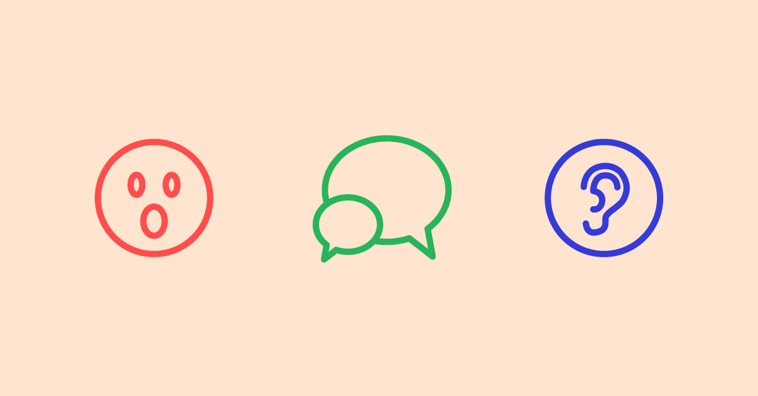
https://www.babbel.com/magazine/static/img/social-sharing-image/en/LangLearningBasic_Illus_FB1200.png

http://www.anenglishaccent.com/Images/consonants.jpg
http://68.media.tumblr.com/fec1095aa634aa92868bd49a4cfc736e/tumblr_inline_mulkb0Rnc91rplshr.png
http://cmed.faculty.ku.edu/ipafolder/vowels.html
Image sources: https://theawesomer.com/tag/willy-wonka/; script from: http://wonkadotcom.tripod.com/script.html; Twenty Thousand Hertz podcast: https://www.20k.org/episodes/themusicinspeech
Originally posted at: http://www.gather.com/viewArticle.jsp?articleId=281474977026713&memberId=13398&startDate=20070606&endDate=20070612

