Read through the following short story, marking shorter pauses with |, and longer ones with ||. Practice using the continuation rise where called for.

Make sure you stress the right syllables, and DON’T stress the ones you shouldn’t!

Watch your “s”s – some should be pronounced /z/! And watch your /e/s – they should be pronounced like ㄟㄧ, even before /n/ and /m/.
And get help from you mentor!

A Lesson From My Dad
by Mary Beth M.
My dad, Big Jim, was a far-from-perfect specimen. But he was Daddy and I was Daddy’s Girl and I loved him, flaws and all.

One day, I came home from school all upset because someone had hurt my feelings. I recounted the story to Daddy, expecting an outpouring of sympathy against this wrongdoing.

“Mary Elizabeth, I’m ashamed of you,” Daddy surprised me by saying. “How can you be so conceited?”

Conceited? Me? Good grief, I was the injured party here, not the culprit. I was in shock.

“For you to think this girl did this to you on purpose is very conceited,” he continued. “Chances are she wasn’t even thinking about you when she did it. Most people are more concerned with what they want than they are with hurting someone else. To deliberately hurt someone takes effort, and most people don’t even think of others as worth the effort.”

I had to think about that one a bit. I remembered all the times I said “I didn’t mean to” when one of my three younger sisters thought I was out to get them, and I had to agree with him. When they charged “Foul,” I usually wasn’t even thinking about them. Maybe he had a point.

“Don’t ever get the idea you’re more important than anyone else,” he warned. “You are no better than anybody out there.”

Well, no problem there. I didn’t think that I thought I was more important than anyone else. But he wasn’t finished.

“No, you’re no better than anyone else around, but by God, you are every bit as good as everybody else!”

Thanks to the lesson Daddy gave me that day, I’ve been able to shrug off a lot of petty incidents as nothing, when I could have been tempted to make them a huge deal. I’d guess a lot of relationships are much smoother for me because of Daddy’s advice. Although he’s been gone more than thirty years, he’s still helping me. I guess that’s one of the benefits of being Daddy’s Girl!
Originally posted at: http://www.gather.com/viewArticle.jsp?articleId=281474977026713&memberId=13398&startDate=20070606&endDate=20070612

Phrasing and intonation

Taiwanese tend to race to the finish when reading, with almost no pauses, making it difficult for listeners to understand. The reader will also not usually understand what they’re reading, and they will sound stressed and nervous. Conscious learning of where to pause can fix this!

A. Pause:
- After the complete subject
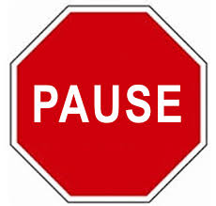
- Before “that” and other clauses
- At most punctuation marks
- Before conjunctions
- Before prepositions
- Parentheticals (e.g. Ted, unfortunately, couldn’t come.)

B. Three Basic Rules of Intonation:
1. Stress content words
(nouns, verbs, adjectives, some adverbs);
don’t stress function words
(articles, conjunctions, prepositions, pronouns,
helping verbs, “be” verbs, some adverbs).
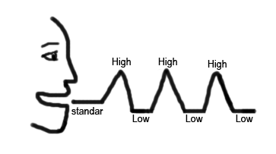
2. Stress new information; don’t stress old information.
3. Stress contrasted words; everything else is unstressed
(a low, flat tone).
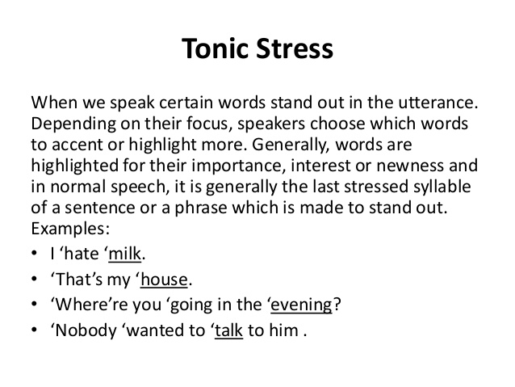

C. * Tonic Stress:
The last stressed syllable in every phrase or thought group gets
an especially high (or low) intonational stress. It’s marked with an *asterisk.

D. Continuation Rise ʅ
ʅ
Taiwanese students tend to have a falling intonation
at the end of all phrases.
But there should be a rise at the end of most phrases
that aren’t the end of a sentence.
The highest point is the tonic stress,
then it falls low, then there’s a gentle rise.

E. Watch out for the pronunciations of these common words:
of [ʌv] or [əv], as [æz], because [bi ‘kʌz], she [ʃi] (NOTㄒㄩ),
says [sɛz] (not [sez] or [seɪz]), said [sɛd] (not [sed] or [seɪd]), ask, asks, asked.

F. Voicing affects vowel length
If the final sound of a syllable is voiced, the vowel that precedes it must be lengthened. Contrast the following: cap/cab [kæp]/[kæːb] lit/lid [lɪt]/[lɪːd] duck/dug [dʌk]/[dʌːg]
lap/lab; mop/mob; pup/pub; cop/cob; rope/robe; bit/bid; pat/pad; sit/Sid; set/said; mutt/mud
G. Compound Noun Stress
In compound nouns, i.e. noun + noun expressions, only the stressed syllable of the modifying noun is stressed. Adjective + noun expressions with special meanings are stressed in this way too. These expressions are stressed as though they were one word.
Examples: convenience store, peanut butter, exercise bike, newspaper, girlfriend, boyfriend, bookshelf, computer desk, airplane, insurance salesman, car door; hot dog, greenhouse, blackboard

